ICH HARMONISED GUIDELINE
ICH Q14: Analytical Procedure Development

(Draft version, Endorsed on 24 March 2022)
指引意見彙整表
段落 | 標題 | 內文 (摘自Q14 draft guideline，仍以ICH文件為準) | 相關建議及意見  (請提供中英文內容)
1. INTRODUCTION
 | 1.1 Objective of the Guideline | This guideline describes science and risk-based approaches for developing and maintaining analytical procedures suitable for the assessment of the quality of drug substances and drug products. The systematic approach suggested in ICH Q8 Pharmaceutical Development together with principles of ICH Q9 Quality Risk Management can also be applied to the development and lifecycle management of analytical procedures. When developing an analytical procedure, a minimal (also known as traditional) approach or elements of an enhanced approach can be applied.  Furthermore, the guideline describes considerations for the development of multivariate analytical procedures and for real time release testing (RTRT).  This guideline is intended to complement ICH Q2 Validation of Analytical Procedures. Submitting knowledge and information related to development of analytical procedures to regulatory agencies may provide additional evidence to demonstrate that the analytical procedure is appropriate for its intended purpose.  Using the tools described in ICH Q12 Technical and Regulatory Considerations for Pharmaceutical Product Lifecycle Management, the guideline describes principles to support change management of analytical procedures based on risk management, comprehensive understanding of the analytical procedure and adherence to predefined criteria for performance characteristics. Knowledge gained from application of an enhanced approach to analytical procedure development can provide better assurance of the performance of the procedure, can serve as a basis for the analytical procedure control strategy and can provide an opportunity for more efficient regulatory approaches to related post approval changes.  The guideline also describes submission of analytical procedure development and related lifecycle information in the Common Technical Document (CTD) format (ICH M4Q, The Common Technical Document for the Registration of Pharmaceuticals for Human Use: Quality – M4Q).
2. SCOPE |  | This guideline applies to new or revised analytical procedures used for release and stability testing of commercial drug substances and products (chemical and biological/biotechnological). The guideline can also be applied to other analytical procedures used as part of the control strategy (ICH Q10, Pharmaceutical Quality System) following a risk-based approach. The scientific principles described in this guideline can be applied in a phase-appropriate manner during clinical development. This guideline may also be applicable to other types of products, with appropriate regulatory authority consultation as needed. Development of pharmacopoeial analytical procedures is out of scope.
 | 2.1 General Considerations for Analytical Procedure Development and Lifecycle Management | The goal of development is to obtain an analytical procedure fit for its intended purpose: to measure an attribute or attributes of the analysed material with the needed specificity/selectivity, accuracy and/or precision over the reportable range.  In this section the minimal and enhanced approaches to analytical procedure development are described. While the minimal approach remains acceptable, some or all elements of the enhanced approach might be used to support development and lifecycle management of analytical procedures.  In certain cases, an established analytical procedure can be applied to multiple products with little or no modification of measurement conditions. For a new application of such platform analytical procedures, the subsequent development can be abbreviated, and certain validation tests can be omitted based on a science- and risk-based justification. Details of the performance characteristics considered for analytical procedure validation are described in ICH Q2.  In general, data gained during the development studies (e.g., robustness data from a design of experiments (DoE study)) can be used as validation data for the related analytical procedure performance characteristics and does not necessarily need to be repeated.
 | 2.2 Minimal versus Enhanced Approaches to Analytical Procedure Development | Minimal Approach  Analytical procedure development should include the following elements as appropriate:  - Identifying which attributes of the drug substance or drug product need to be tested by the analytical procedure.  - Selecting an appropriate analytical procedure technology and related instruments or suitable apparatus.  - Conducting appropriate development studies to evaluate analytical procedure performance characteristics such as specificity, accuracy and precision over the reportable range (including the calibration model, limits at lower and/or higher range ends) and robustness.  - Defining an appropriate analytical procedure description including the analytical procedure control strategy (e.g., parameter settings and system suitability).  Enhanced Approach  The enhanced approach offers a systematic way of developing and refining knowledge of an analytical procedure. An enhanced approach should include one or more of the following elements in addition to those already described for the minimal approach:  - An evaluation of the sample properties and the expected variability of the sample based on manufacturing process understanding.  - Defining the analytical target profile (ATP).  - Conducting risk assessment and evaluating prior knowledge to identify the analytical procedure parameters that can impact performance of the procedure.  - Conducting uni- or multi-variate experiments to explore ranges and interactions between identified analytical procedure parameters.  - Defining an analytical procedure control strategy based on enhanced procedure understanding including appropriate set-points and/or ranges for relevant analytical procedure parameters ensuring adherence to performance criteria.  - Defining a lifecycle change management plan with clear definitions and reporting categories of established conditions (ECs), proven acceptable ranges (PARs) or method operational design regions (MODRs) as appropriate.  Applying elements of the enhanced approach to development can lead to more robust analytical procedures, better understanding of the impact of analytical procedure parameters and more flexibility for lifecycle management such as wider operating ranges, a more appropriate set of ECs and associated reporting categories for changes.  The enhanced approach potentially offers several advantages, including:  - Understanding of which analytical procedure attributes are essential to procedure performance (i.e., ECs).  - Employing predefined performance characteristics (e.g., in the ATP) linked to critical quality attributes (CQAs) and their acceptance criteria to provide purpose driven protocols for validation of analytical procedures and for future comparisons between current and new analytical procedures/technologies.  - Improving analytical procedure control resulting in more reliable operation.  - Enabling preventative measures and facilitating continual improvement by using more analytical procedure knowledge.  - Reducing the amount of effort across the analytical procedure lifecycle.
 | 2.3 The Analytical Procedure Lifecycle | Figure 1 depicts elements of the analytical procedure lifecycle. Analytical procedure development and change management approaches are described in this guideline whereas analytical procedure validation is described in ICH Q2. Depending on the intended use of the analytical procedure and the development approach taken, the order and extent of each element could vary, and several elements could occur simultaneously.  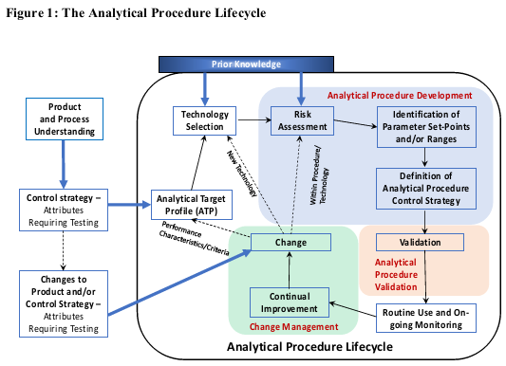
3. ANALYTICAL TARGET PROFILE (ATP) |  | Product and process understanding (ICH Q8 and ICH Q11 Development and Manufacture of Drug Substances) leads to the identification of quality attributes requiring analytical measurement for control which are described (for example) in a quality target product profile (QTPP). Measurement needs can be captured in an ATP which forms the basis for development of the analytical procedure.  An ATP consists of a description of the intended purpose, appropriate details on the product attributes to be measured and relevant performance characteristics with associated performance criteria. The ATP includes the performance requirements for a single attribute or a set of quality attributes. The ATP drives the choice of analytical technology. Multiple available analytical techniques may meet the performance requirements. Consideration of the operating environment (e.g., at-line, in-line or off-line) should be included in the technology selection. Once a technology has been selected, the  ATP serves as a foundation to derive the appropriate analytical procedure attributes and acceptance criteria for analytical procedure validation (ICH Q2). Formal documentation and submission of an ATP is optional but can facilitate regulatory communication irrespective of the chosen development approach.  The ATP facilitates the selection of the technology, the procedure design and development as well as the subsequent performance monitoring and continual improvement of the analytical procedure. The ATP is maintained over the lifecycle and can also be used as a basis for lifecycle management to ensure that the analytical procedure remains suitable for the intended use.  Illustrative examples of ATPs are provided in Annex A.
4. KNOWLEDGE AND RISK MANAGEMENT IN ANALYTICAL PROCEDURE
DEVELOPMENT AND CONTINUAL IMPROVEMENT

 | 4.1 Knowledge Management | As with product and manufacturing process development (ICH Q10), knowledge management plays a critical role in analytical procedure development and during the subsequent lifecycle of the analytical procedure.  Prior knowledge is explicitly or implicitly used for informing decisions during analytical procedure development and lifecycle management. Prior knowledge can be internal knowledge from a company’s proprietary development and analytical experience, external knowledge such as reference to scientific and technical publications or established scientific principles.  Prior product knowledge plays an important role in identifying the appropriate analytical technique. Knowledge of best practices and current state-of-the-art technologies as well as current regulatory expectations contributes to the selection of the most suitable technology for a given purpose. Existing platform analytical procedures (e.g., protein content determination by UV spectroscopy for a protein drug) can be leveraged to evaluate the attributes of a specific product without conducting additional procedure development.  As additional information is obtained, knowledge related to analytical procedures should be actively managed throughout the product lifecycle.
 | 4.2 Risk Management | The use of quality risk management is encouraged to aid in the development of a robust analytical procedure to reduce risk of poor performance and reporting incorrect results. Risk assessment is typically performed early in analytical procedure development and is repeated as more information becomes available. Risk assessment can be formal or informal and can be supported by prior knowledge.  Risk assessment tools as described in ICH Q9 Annex 1 can be used to  - identify analytical procedure parameters (factors and operational steps) with potential impact on its performance, e.g., Annex A Figures 1 and 2 (Ishikawa diagrams).  - assess the potential impact of analytical procedure parameters on the analytical procedure performance.  - identify and prioritise analytical parameters to be investigated experimentally.  Risk control principles can be used to establish an analytical procedure control strategy. To maintain a state of control for analytical procedure performance, ongoing monitoring is recommended as part of risk review.  Risk communication should be used to support continual improvement of the analytical procedure performance throughout its lifecycle. The outcome of quality risk management should be documented within the applicant’s pharmaceutical quality system (PQS).
5. EVALUATION OF ROBUSTNESS AND PARAMETER RANGES OF ANALYTICAL
PROCEDURES

 | 5.1 Robustness | The robustness of an analytical procedure is a measure of its capacity to meet the expected performance requirements during normal use. Robustness is tested by deliberate variations of analytical procedure parameters. Prior knowledge and risk assessment can inform the selection of parameters to investigate during the robustness study. Those parameters likely to influence procedure performance over the intended period of use should be studied.  For most procedures, robustness evaluation is conducted during development. If the evaluation of robustness was already conducted during development, it does not need to be repeated during validation as discussed in ICH Q2. Data from validation studies (e.g., intermediate precision) can be used to complement robustness evaluation. For some analytical procedures with inherent high parameter variability (e.g., those requiring biological reagents) wider ranges may need to be investigated during robustness studies. Robustness of multivariate procedures may require additional considerations (see chapter 8). The outcome of the evaluation of robustness should be reflected in the analytical procedure control strategy.
 | 5.2 Analytical Procedure Parameter Ranges | Experiments to investigate parameter ranges can provide additional knowledge about the analytical procedure performance. The respective analytical procedure attributes and associated criteria could be derived from the ATP. Univariate examination of a single parameter can establish proven acceptable ranges (PAR) for the analytical procedure.  In an enhanced approach, the ranges for the relevant parameters and their interactions can be investigated in multi-variate experiments (DoE). Risk assessment and prior knowledge should be used to identify parameters, attributes and appropriate associated ranges to be investigated experimentally. Categorical variables (e.g., different instruments) can also be considered as part of the experimental design.  The outcome of development studies including DoE can provide an understanding of the relationships between analytical procedure variables (inputs) and the responses of the analytical procedure (outputs). Based on the results, fixed set-points may be defined for some parameters. For others, PARs could be defined while still others could be included into an MODR. An MODR consists of combined ranges for two or more variables within which the analytical procedure is shown to be fit for the intended use.  Parameter ranges (e.g., PAR or MODR) can be proposed by the applicant based on development data and are subject to regulatory approval. Moving within an established parameter range does not require regulatory notification.  For practical reasons and following a risk-based approach, it may not be necessary or possible to validate the entirety of a MODR. The part of a PAR or a MODR intended for routine use in the analytical procedure must be covered by validation data. Validation approaches for MODRs are described in Annex B including an example table to present the performance characteristics combined with the analytical procedure attribute acceptance criteria, parameter ranges, analytical procedure control strategy and validation strategy. Analytical procedure validation is required only for those performance characteristics not covered by data from analytical procedure development. An analytical procedure validation strategy, e.g., as part of the analytical procedure validation protocol, can define the necessary extent of additional validation.
6. ANALYTICAL PROCEDURE CONTROL STRATEGY |  | An analytical procedure control strategy should ensure that the analytical procedure performs as expected during routine use throughout its lifecycle and consists of a set of controls, derived from current understanding of the analytical procedure including development data, risk assessment and robustness. Prior knowledge could also be used to develop the analytical procedure control strategy. The analytical procedure control strategy should be defined before validation (ICH Q2) and should be confirmed after validation has been finalized.  The analytical procedure control strategy includes analytical procedure parameters needing control and the system suitability test (SST) which is part of the analytical procedure description. The analytical procedure description should include the steps necessary to perform each analytical test. This can include (but is not limited to) the sample, the reference materials and the reagents, sample and control preparations, use of the apparatus, generation of the calibration curve, use of the formulae for the calculation of the reportable results and other necessary steps. The level of detail should enable a skilled analyst to perform the analysis and interpret the results (such as the level of detail in a regional pharmacopoeia for a similar substance).  The SST depends on the type and intent of the analytical procedure and is typically conducted with one or more predefined materials (including use of positive or negative controls). The SST is designed to verify selected analytical procedure attributes. The acceptance criteria should be based on analytical procedure performance criteria. The components of the SST should be selected using risk assessment as well as knowledge and understanding from development data. The test is used to verify that the measurement system and the analytical operations associated with the analytical procedure are adequate during the intended time period of analysis and enable the detection of potential failures. Validity of the results of the analytical procedure depends on the outcome of the SST. In the enhanced approach, a well-designed set of SST parameters and criteria to ensure method performance could represent an important aspect of risk mitigation. For analytical procedures relying on multivariate models, data quality should be verified using appropriate software tools.  In addition to SST, sample suitability assessment may be required to ensure acceptable sample response. A sample and/or sample preparation is considered suitable if the measurement response of the sample satisfies pre-defined acceptance criteria for the analytical procedure attributes that have been developed for the validated analytical procedure (often used for biologics). In these cases, sample suitability is a prerequisite for the validity of the result along with a satisfactory outcome of the SST. For analytical procedures relying on multivariate models, sample suitability assessment can be verified using appropriate software tools which check if the sample fits within the model space. This is commonly called data quality check.  Ongoing monitoring of selected analytical procedure outputs is recommended to look for any trends, in line with PQS expectations. Review of analytical procedure outputs facilitates the procedure lifecycle management and enables proactive intervention to avoid failures.
 | 6.1 Established Conditions for Analytical Procedures | In line with ICH Q12, applicants may define established conditions (ECs) for an analytical procedure. ECs are proposed and justified by the applicant and approved by the regulatory authorities. ECs can be identified using tools highlighted in Chapter 4 including risk assessment, prior knowledge, and learnings from uni- and/or multi-variate experimentation. The nature and extent of ECs will depend on the development approach, the complexity of the analytical procedure and a demonstrated understanding of how parameters and other factors impact its performance.  With a minimal approach to development, the number of ECs may be extensive with fixed analytical procedure parameters and set points.  With an enhanced approach to development, there should be an increased understanding of the relationship between analytical procedure parameters and performance to facilitate identification of which factors require control and thus enable a more appropriate set of ECs. These can focus on performance characteristics (e.g., specificity, accuracy, precision).  ECs could consist of performance criteria (e.g., in the ATP or as part of SST), the analytical procedure principle (i.e., the physicochemical basis or specific technology), and set points and/or ranges for one or more parameters. Analytical procedure parameters which need to be controlled to ensure the performance of the procedure as well as those where the need for control cannot be reasonably excluded should be identified as ECs. If a parameter is controlled through performance characteristics and criteria, that parameter may not necessarily need to be defined as an EC or may be assigned a  lower reporting category.  Use of the enhanced approach should not lead to providing a less detailed description of analytical procedures in a regulatory submission. A suitably detailed description of the analytical procedures in Module 3 of the CTD is expected to provide a clear understanding regardless of the approach used to identify ECs for analytical procedures. Description of analytical procedures can include supportive information as well as identified ECs.  Identification of reporting categories for ECs and the utilization of ECs in change management are described in the next chapter.
7. LIFECYCLE MANAGEMENT AND POST-APPROVAL CHANGES OF ANALYTICAL  PROCEDURES |  | Changes to analytical procedures can occur throughout the product lifecycle and could involve modification of existing procedures or a complete replacement including introduction of a new technology. Major changes in the performance characteristics or additional information on attributes could, in certain instances, lead to reevaluation of the ATP itself and/or a new procedure. Typically, process knowledge, analytical procedure knowledge and continual improvement are drivers for change. If possible, changes should lead to improved analytical procedures in line with best practices and instrumentation. The tools and enablers discussed in ICH Q12 are applicable to analytical procedures, irrespective of the development approach and consist of:  - Existing risk-based categorisation of changes to analytical procedures (in applicable regional regulatory framework)  - Ecs  - Post-Approval Change Management Protocols (PACMPs) which provide a detailed explanation of how future changes will be managed and provide the marketing authorization holder (MAH) with certainty about the acceptability of future changes and an associated reduced reporting category.  - The Product Lifecycle Change Management (PLCM) document which can facilitate regulatory communication about likely post-approval changes.  - The PQS (documentation of all changes including those not requiring regulatory submission, e.g., within a MODR or for parameters deemed not to have an impact on the method performance)  - The structured approach to frequent CMC changes (ICH Q12 Chapter 8).  If a minimal approach to development is taken, then any changes should be reported according to existing regional reporting requirements. The use of different elements of the enhanced approach can facilitate management and regulatory communication of post-approval changes.  If appropriately justified and validated (see Chapter 5.2), a PAR or MODR allows flexibility within the approved range(s) to be managed within a company’s PQS. Changes outside of the approved ranges or expansion of said ranges require regulatory reporting.  In cases where ECs are proposed, the risk associated with prospective changes should be assessed up front to define the appropriate reporting category. Factors to consider include the importance of the quality attribute being measured, the complexity of the technology and the extent of the change. Relevant risk reduction measures should be identified based on product and process knowledge as well as analytical procedure understanding and the proposed analytical procedure control strategy. Finally, the level of risk (high, medium or low) should be assigned.  In general, an understanding of the analytical procedure robustness and/or prior knowledge can be used to support risk mitigation associated with future changes. Submitting the outcomes of the risk assessments to regulatory agencies when ECs are identified can help justify reporting categories for future changes to analytical procedures.  Figure 2 summarizes how risk assessment and risk reduction measures can help identify appropriate reporting categories for ECs. Fixing performance criteria for performance characteristics identified as ECs, for example, in an ATP, can help mitigate risk associated with changes. This ensures that the analytical procedure remains fit for purpose subsequent to changes and thus forms the basis of a bridging strategy. Changes to parameters that are not ECs should be documented in the PQS but do not require regulatory reporting.  The ATP could also form the basis of a PACMP which would allow changes (e.g., a change between technologies) to be reported at a lower reporting category provided that the pre-defined requirements for a change are met.  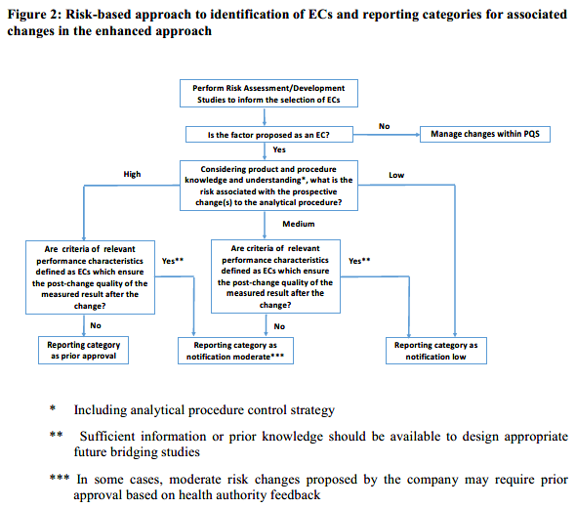  In Annex A examples are given on how appropriate reporting categories can be proposed.  When implementing changes to analytical procedures, QRM can be used to evaluate the impact of the changes and re-confirm that the originally agreed reporting category is still appropriate. The outcome of this risk assessment informs the design and extent of the studies needed to support the change including an appropriate bridging strategy to demonstrate that the revised or new procedure is fit for purpose. The implementation of an already validated analytical procedure at a different location, including the concepts of the analytical procedure transfer, should follow the same verification and bridging strategies (Tables 1 and 2).  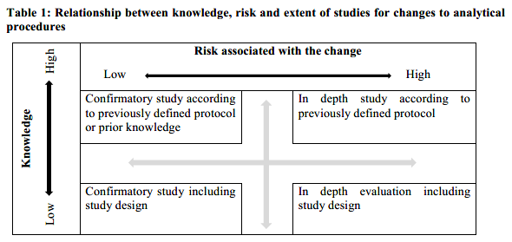  For product and process changes, a re-assessment and potential adaptation of the ATP, if used, and a re-assessment of the suitability of the analytical procedure may be necessary.  If an applicant proposes a new analytical procedure, a thorough risk assessment and evaluation should be conducted to determine any impact on the performance. The analytical procedure control strategy for the new procedure should be established. ECs associated with the new procedure should be justified when reporting the change.  Table 2 provides examples of data recommended to support a change dependent on the extent of the change and the identified risk category.  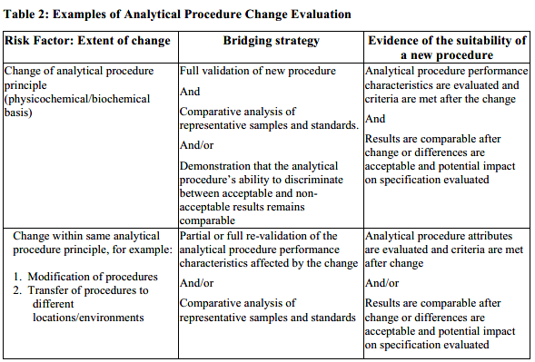  To support the use of the tools described in this guideline, the company´s PQS change management process should be effective and in line with recommendations described in ICH Q12. During the lifecycle the MAH should evaluate performance, perform trend analysis, assess knowledge gained and re-evaluate if the analytical procedure remains fit for purpose.
8. DEVELOPMENT OF MULTIVARIATE ANALYTICAL PROCEDURES |  | Multivariate analytical procedures are those where a result is determined through a multivariate calibration model utilizing more than one input variable. The considerations provided here are for models using latent variables that are mathematically related to directly measured variables. Other approaches, in machine learning, such as neural networks, or optimization techniques could use similar principles although the specific approach may vary and will not be discussed in detail.  Development of a robust multivariate analytical procedure includes scientifically justified sample selection and distribution over the range, sample size, model variable selection and data pre-processing.  Sample and sample population  Multivariate models link measured model variables with values obtained from a validated reference procedure or from reference samples. Therefore, samples in multivariate analysis consist of input measurements and their corresponding reference values, which are numeric values for quantitative measurements (e.g., assay) and classification categories for qualitative methods (e.g., identity). In some cases, one set of input measurements could be used for multiple models provided that more than one reference value exists. The reference values are determined using reference analytical procedure(s) or prepared reference samples with known values. Care should be taken to ensure that uncertainty in the reference analytical procedure is sufficiently low in relation to the intended performance of the multivariate analytical procedure and that prepared reference samples are homogeneous. The approach to the reference procedure(s) or prepared reference samples should be explained and justified.  The ranges of multivariate models are typically constructed by data from samples. Therefore, a careful strategy for sample selection is essential for obtaining the relevant information from the analytical data and contributes to the robustness of the resulting model. Based on the method and measurement principle, the sample population should encompass the sources of variability likely to occur during manufacture and analysis, such as raw material quality, manufacturing process variability, storage conditions, sample preparation and testing. Use of risk assessment tools can help to identify sources of variability with the potential to influence the measurements and resulting model outputs.  Obtaining samples with appropriate variability at commercial scale can be challenging. Therefore, development laboratory and pilot scale samples are often utilized to provide enough variability to improve accuracy and robustness of the model. Inclusion of commercial scale samples is recommended to capture variability related to specific equipment and/or processing conditions. Careful consideration should also be given to sample distribution in the calibration and validation sets, as this will influence the model predictive capability.  The number of samples used to create a calibration model for quantitative analysis will depend on the complexity of the sample matrix and/or interference by the matrix in the analyte signal of interest (i.e., for more complex sample matrices, generally more samples are needed).  Sufficient samples should be available to allow for creation of independent calibration and validation sets of appropriate size and variability, i.e., samples in the validation set are not incorporated in calibration or internal testing sets. A validation sample set generated with samples from independent batches can be used to demonstrate model robustness.  Variable selection  Variable selection is performed during model development. For example, wavelength range selection is frequently applied in spectroscopic applications to select a region of a spectrum that gives the best estimation of the selected chemical or physical property to be evaluated (modeled). Variable selection depends on the measurement principle, application and other factors, and should be justified.  Data transformation  The selection of the data transformation method(s) can be driven by the type of data, instrument or sample, the intended use of the model and/or prior knowledge. Caution should be exercised when performing any transformation because artefacts can be introduced, or essential information lost. Any transformation of data should be documented and justified.  Robustness  Model development should minimize the prediction error and provide a robust model that consistently assures the long-term performance of multivariate models. The robustness should be built into the model by including relevant sources of variability related to materials, process, environment, instrumentation or other factors. Sources of variability can be identified from prior knowledge and risk assessments and evaluated using statistical tools. Robustness depends on multiple factors, e.g., composition of the calibration set, data transformation method, variable selection and the number of latent variables.  Optimization of the multivariate model is an important step in development and often requires a trade-off between accuracy and robustness. A critical factor is the number of latent variables to be used in the calibration model which ensures the model is optimized for its intended purpose. Selection of the number of latent variables occurs during model development and is confirmed during internal testing.  Too many latent variables can result in model overfitting, potentially resulting in decreased  robustness and a need for more frequent model updates. Justification for the final number of latent variables used should be provided. Diagnostic plots provided by software packages can be useful to support the justification.  Re-calibration and model maintenance  Tracking the calibration model performance is an important part of ongoing monitoring for a multivariate analytical procedure. Various statistical tools can be employed as diagnostics to ensure that the model assumptions are upheld. For latent variable models, these diagnostic tools can include:  - examination of residuals to determine unmodeled features of the data (e.g., x-residuals or F-probability)  - outlier diagnostics to determine if the data is within the bounds of the model construction (e.g., Hotelling’s T-squared or Mahalanobis distance)  Software packages allow for the application of diagnostic tools for every model prediction.  Additionally, continued performance of the calibration model should be confirmed on a periodic and event-driven basis by comparison of the model predictions with the reference samples or reference method results. This confirmatory testing helps to ensure that the calibration model continues to perform as expected. Examples of events that could trigger confirmatory testing include new known process variability, unexpected process events or scheduled instrument maintenance.  Monitoring of the model can be used to trigger model rebuilding (recalibration) as a part of continual improvement. In general, the same considerations hold as for the original model building and internal testing. Based on the cause of the model update (e.g., a process shift), new data may need to be included and old non-relevant data may be taken out.  Once the new calibration model is established, the updated analytical procedure can be validated against the same performance criteria as the one included in the original model. Aspects that are not expected to change from the model update may not need to be evaluated (e.g., specificity).  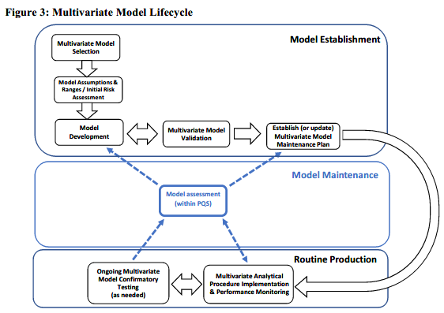  The multivariate model lifecycle is iterative and can be broken down into 3 major components: (1) model establishment, (2) routine production and (3) model maintenance.  The choice of a multivariate model is based on the analytical procedure requirements and the measurement technology selected. Prior to model development, the performance factors for the model are defined, including the underlying model assumptions and desired ranges for model applicability. An initial risk assessment can be valuable to understand potential sources of variability in the materials and process that could affect the model performance and therefore should be considered during the model calibration. Model development, including calibration and internal testing, follows the considerations outlined in this chapter. Once the model is developed, it is validated using independent data not previously used in the calibration set. The last step in model establishment is development of a multivariate model maintenance plan, which includes the procedures and limits for outlier diagnostics, and defines the frequency and circumstances for confirmatory testing, if needed.  Routine analysis of the multivariate analytical procedure typically includes monitoring the  appropriateness of every measurement using outlier diagnostics. Confirmatory testing against a reference procedure is recommended on a pre-defined periodic or event driven basis (e.g., equipment maintenance, new raw materials or process changes). Model assessment can be triggered by failure of confirmatory testing or outlier diagnostics to meet the predefined criteria, or from data trending indicating potential issues with the model, the process or the materials being measured (examples of multivariate model lifecycle components are provided in Annex C).  Model assessment is performed within the PQS and utilizes knowledge management and risk assessment. If an issue is identified, model development and revalidation may be needed, for example, to add samples into the calibration set and remove those that are no longer relevant. In some cases, the model may be performing appropriately, but additional experience may identify the need to modify the limits of the model maintenance plan. In other cases, the issue identified could be related to the measurement system (e.g., a misaligned sample interface) and no model update would be needed. The dashed arrows in the figure illustrates reintroduction into the lifecycle flow based on the potential outcomes of the model assessment.
9. DEVELOPMENT OF ANALYTICAL PROCEDURES FOR REAL TIME RELEASE  TESTING: SPECIAL CONSIDERATONS |  | Real Time Release Testing (RTRT) is the ability to evaluate and ensure the quality of in-process and/or final product based on process data, which typically include a valid combination of measured material attributes and process controls (ICH Q8). RTRT measurements work in conjunction with all elements of the control strategy (e.g., process monitoring or in-process controls) to ensure product quality. RTRT can be applied to active substances, intermediates and finished products.  RTRT can be based on an appropriate combination of one or more process measurements and/or material attributes to provide a prediction of one or more product CQAs and needs to be specific for that CQA. The relationship between the RTRT approach and the product CQAs, as well as acceptance criteria, should be fully justified. As appropriate, an RTRT procedure should be validated as recommended in ICH Q2 and it should be demonstrated that the process measurements have appropriate specificity for the targeted product quality attribute.  Sampling and the sample interface are important considerations when designing any on-line or in-line test method, including those used for RTRT. The measurement point(s) should be chosen to be representative of the entire material being processed with the sample duration or amount appropriately chosen (e.g., relative to a unit dose). Additionally, the sample interface should remain consistent over the duration of manufacturing and should be robust to expected processing and environmental variations.  The RTRT approach should be included in the product specification along with a reference to the RTRT analytical procedure(s) and the related acceptance criteria, which are discussed in ICH Q6A and Q6B. Quantitative RTRT results should be expressed in the same units as those for traditional testing. The product specification will typically also include the analytical procedures to be used for off-line testing. If the dossier includes a registered alternate control strategy to RTRT (e.g., traditional end-product testing for when process analytics are unavailable), the related analytical procedures and when they would be applied should also be included in the submitted product specifications.
10. SUBMISSION OF ANALYTICAL PROCEDURE RELATED INFORMATION
 | 10.1 General Regulatory Considerations and Documentation | The analytical procedure description(s) should be included in the ICH M4Q CTD section 3.2.S.4.2 for drug substance or section 3.2.P.5.2 for drug product. Validation data and any supportive information needed to justify the analytical procedure control strategy should be included in the CTD section 3.2.S.4.3 for drug substance or section 3.2.P.5.3 for drug product. Other analytical procedures used as part of the control strategy can be included in relevant CTD sections (e.g., 3.2.S.2, 3.2.P.3 and 3.2.P.4). The analytical procedure should describe the steps in sufficient detail for a skilled analyst to perform the analysis as elaborated in Chapter 6. Submission of validation data should follow the recommendations in ICH Q2. The criteria used in the validation study should be included in the submission. In some cases, depending on the intended use (e.g., dissolution testing) and/or the selected technique it may be appropriate to submit development data as justification.  Where ECs are proposed for analytical procedures as elaborated in Chapter 6, the ECs should be clearly differentiated from supportive information. Additional development and validation information can be included in sections 3.2.S.4.3 and 3.2.P.5.3 to justify ECs and their reporting categories. When other lifecycle management elements as described in ICH Q12 are included in the submission, the applicant should follow the principles described in ICH Q12 and Chapter 7 of this document.
 | 10.2 Documentation for the Enhanced Approach | If an enhanced approach to development leads to the incorporation of enhanced elements into the analytical procedure control strategy, then these should be justified. Performance characteristics and acceptance criteria (e.g., described in an ATP) and other elements of the enhanced approach (e.g., MODRs or PARs), should be described in the dossier sections for analytical procedure description (e.g., 3.2.S.4.2 and 3.2.P.5.2). If ECs are proposed, then these should also be included in the analytical procedure description, accompanied by supportive information. Use of the enhanced approach should not lead to providing a less detailed description of analytical procedures in a regulatory submission.  If ECs are proposed, risk-based categorization of changes and corresponding reporting categories should be included in the submission. Appropriate justification should be given for parameters that are ECs and those that are not ECs (see Chapter 6). For parameters that are not ECs and are typically not included in a minimal procedure description a justification is not expected.  Appropriate information from analytical procedure risk assessment and development studies to support the proposed lifecycle management strategy should be summarized and submitted in the regulatory submission sections for analytical procedure validation (e.g., 3.2.S.4.3 and 3.2.P.5.3).
 | 10.3 Documentation for Multivariate Analytical Procedures and RTRT | Development information related to multivariate analytical procedures should be provided commensurate with the level of impact of the model (Guide for ICH Q8/Q9/Q10 Implementation). The process development section of the dossier (e.g., 3.2.S.2.6 or 3.2.P.2) should include the model development information for multivariate models used as part of manufacturing development studies or for in-process controls or tests. Supportive development information for RTRT multivariate models can be included in either the appropriate analytical procedure validation or process development section.  Validation information for multivariate analytical procedures used for release of drug product or drug substance, including RTRT, should be included in the validation information section of the dossier (e.g., 3.2.S.4.3 or 3.2.P.5.3). Additionally, these sections should include validation information on analytical procedures used as reference methods. The model development, calibration and validation information can be included directly in the CTD section or be in an appended document.  For multivariate models used as part of drug substance or drug product specifications, including RTRT approaches, the description of the validation approach and results should include:  - Description of the independent validation sample set  - The performance criteria to be met during validation of the multivariate model  - Evaluation of the model validation results against the performance criteria  - Discussion of the relationship between the model performance criteria and the attribute specification limits  - High level overview of the PQS elements for model monitoring and maintenance, such as diagnostic tools for determining the appropriateness of the sample data for the model and the approach taken when outliers are identified.  The description of the multivariate analytical procedure used for RTRT should be provided in the CTD section 3.2.S.4.2 for drug substance or section 3.2.P.5.2 for drug product and typically includes:  - The property or attribute of interest to be determined by the multivariate analytical procedure and the desired quantitative ranges or limits  - A description of the measurement principle and pertinent instrument operating parameters (e.g., sample presentation, sample interrogation time and measurement frequency)  - An overview of how the multivariate model calibration data are obtained (e.g., sample preparation approach, reference method)  - The type of multivariate model (e.g., principal component analysis)  - A description of reference analytical procedure or high-level description of prepared reference samples preparation  - Any calculations needed to adjust the model output into the reported value  Additionally, section 3.2.S.4.2 for drug substance or section 3.2.P.5.2 for drug product should include description of any analytical procedures that are part of a registered alternate control strategy to RTRT.
11. GLOSSARY |  | ACCURACY  The accuracy of an analytical procedure expresses the closeness of agreement between the value which is accepted either as a conventional true value or as an accepted reference value and the value measured. (ICH Q2)  ANALYTICAL PROCEDURE  The analytical procedure refers to the way of performing the analysis. The analytical procedure description should include in detail the steps necessary to perform each analytical test. (ICH Q2)  ANALYTICAL PROCEDURE ATTRIBUTE  A technology specific property that should be within an appropriate limit, range, or distribution to ensure the desired quality of the measured result. For example, attributes for chromatography measurements may include peak symmetry factor and resolution. (ICH Q14)  ANALYTICAL PROCEDURE CONTROL STRATEGY  A planned set of controls derived from current analytical procedure understanding that ensures the analytical procedure performance and the quality of the measured result. (ICH Q14)  ANALYTICAL PROCEDURE PARAMETER  Any factor (including reagent quality) or analytical procedure operational step that can be varied continuously (e.g., flow rate) or specified at controllable, unique levels. (ICH Q14)  ANALYTICAL PROCEDURE VALIDATION STRATEGY  An analytical procedure validation strategy describes how to select the analytical procedure performance characteristics for validation. In the strategy, data gathered during development studies (e.g., using MODR or PAR) and system suitability tests (SSTs) can be applied to validation and an experimental scheme for future movements of parameters within an MODR/PAR can be predefined. (ICH Q14)  ANALYTICAL TARGET PROFILE (ATP)  A prospective summary of the performance characteristics describing the intended purpose and the anticipated performance criteria of an analytical measurement. (ICH Q14)  CALIBRATION MODEL  A model based on analytical measurements of known samples that relates the input data to a value for the property of interest (i.e., the model output). (ICH Q2)  CONTROL STRATEGY  A planned set of controls, derived from current product and process understanding, that assures process performance and product quality. The controls can include parameters and attributes related to drug substance and drug product materials and components, facility and equipment operating conditions, in-process controls, finished product specifications, and the associated methods and frequency of monitoring and control. (ICH Q10)  CO-VALIDATION  Demonstration that the analytical procedure meets its predefined performance criteria when used at different laboratories for the same intended purpose. Co-validation can involve all (full revalidation) or a subset (partial revalidation) of performance characteristics potentially impacted by the change in laboratories. (ICH Q2)  CRITICAL QUALITY ATTRIBUTE (CQA)  A physical, chemical, biological or microbiological property or characteristic that should be within an appropriate limit, range or distribution to ensure the desired product quality. (ICH Q8)  CROSS-VALIDATION  Demonstration that two or more analytical procedures meet the same predefined performance criteria and can therefore be used for the same intended purpose. (ICH Q2)  DETECTION LIMIT  The detection limit is the lowest amount of an analyte in a sample which can be detected but not necessarily quantitated as an exact value. (ICH Q2)  DETERMINATION  The reported value(s) from single or replicate measurements of a single sample preparation as per the validation protocol. (ICH Q2)  ESTABLISHED CONDITIONS (ECs)  ECs are legally binding information considered necessary to assure product quality. As a consequence, any change to ECs necessitates a submission to the regulatory authority. (ICH Q12)  INTERMEDIATE PRECISION  Intermediate precision expresses within-laboratories variations. Factors to be considered should include potential sources of variability, for example, different days, different environmental conditions, different analysts and different equipment. (ICH Q2)  KNOWLEDGE MANAGEMENT  A systematic approach to acquiring, analysing, storing and disseminating information related to products, manufacturing processes and components. (ICH Q10)  METHOD OPERABLE DESIGN REGION (MODR)  A combination of analytical procedure parameter ranges within which the analytical procedure performance criteria are fulfilled and the quality of the measured result is assured. (ICH Q14)  ONGOING MONITORING  The collection and evaluation of analytical procedure performance data to ensure the quality of measured results throughout the analytical procedure lifecycle. (ICH Q14)  PERFORMANCE CHARACTERISTIC  A technology independent description of a characteristic to ensure the quality of the measured result. Typically, accuracy, precision, specificity/selectivity and range may be considered. The term was previously called VALIDATION CHARACTERISTIC. (ICH Q2)  PERFORMANCE CRITERION  An acceptance criterion describing a numerical range, limit or desired state to ensure the quality of the measured result. (ICH Q14)  PLATFORM ANALYTICAL PROCEDURE  A platform analytical procedure can be defined as a multi-product method suitable to test quality  attributes of different products without significant change to its operational conditions, system  suitability and reporting structure. This type of method would apply to molecules that are sufficiently  alike with respect to the attributes that the platform method is intended to measure. (ICH Q2)  PRECISION  The precision of an analytical procedure expresses the closeness of agreement (degree of scatter) between a series of measurements obtained from multiple samplings of the same homogeneous sample under the prescribed conditions. Precision can be considered at three levels: repeatability, intermediate precision and reproducibility.  The precision of an analytical procedure is usually expressed as the variance, standard deviation or coefficient of variation of a series of measurements. (ICH Q2)  PROVEN ACCEPTABLE RANGE FOR ANALYTICAL PROCEDURES (PAR)  A characterised range of an analytical procedure parameter for which operation within this range, while keeping other parameters constant, will result in an analytical measurement meeting relevant performance criteria. (ICH Q14)  QUALITY RISK MANAGEMENT  A systematic process for the assessment, control, communication and review of risks to the quality of the drug (medicinal) product across the product lifecycle. (ICH Q9)  QUANTITATION LIMIT  The quantitation limit is the lowest amount of analyte in a sample which can be quantitatively determined with suitable precision and accuracy. The quantitation limit for an analytical procedure should not be more than the reporting threshold. The quantitation limit is a parameter used for quantitative assays for low levels of compounds in sample matrices, and, particularly, is used for the determination of impurities and/or degradation products. (ICH Q2)  RANGE  The range of an analytical procedure is the interval between the lowest and the highest reportable results in which the analytical procedure has a suitable level of precision, accuracy and response. (ICH Q2)  REPORTABLE RANGE  The reportable range of an analytical procedure includes all values from the lowest to the highest reportable result for which there is a suitable level of precision and accuracy. Typically, the reportable range is given in the same unit as the specification. (ICH Q2)  WORKING RANGE  The working range of an analytical procedure is the lowest and the highest concentration that the analytical procedure provides meaningful results. Working ranges may be different before sample preparation (sample working range) and when presented to the analytical instrument (instrument working range). (ICH Q2)  REAL TIME RELEASE TESTING (RTRT)  The ability to evaluate and ensure the quality of the in-process and/or final product based on process data, which typically include a valid combination of measured material attributes and process controls. (ICH Q8)  REPEATABILITY  Repeatability expresses the precision under the same operating conditions over a short interval of time. Repeatability is also termed intra-assay precision. (ICH Q2)  REPORTABLE RESULT  The result as generated by the analytical procedure after calculation or processing and applying the described sample replication. (ICH Q2)  REPRODUCIBILITY  Reproducibility expresses the precision between laboratories (e.g., inter-laboratory studies, usually applied to standardization of methodology). (ICH Q2)  RESPONSE  The response of an analytical procedure is its ability (within a given range) to obtain a signal which is effectively related to the concentration (amount) of analyte in the sample by some known mathematical function. (ICH Q2)  REVALIDATION  Demonstration that an analytical procedure is still fit for its intended purpose after a change to the product, process or the analytical procedure itself. Revalidation can involve all (full revalidation) or a subset (partial revalidation) of performance characteristics. (ICH Q2)  ROBUSTNESS  The robustness of an analytical procedure is a measure of its capacity to meet the expected performance requirements during normal use. Robustness is tested by deliberate variations of analytical procedure parameters. (ICH Q14)  SAMPLE SUITABILITY ASSESSMENT  A sample or sample preparation is considered suitable if the measurement response on the sample satisfies pre-defined acceptance criteria for the analytical procedure attributes that have been developed for the validated analytical procedure. Sample suitability is a pre-requisite for the validity of the result along with a satisfactory outcome of the system suitability test. Sample suitability assessment generally consists of the assessment of the similarity of the response between a standard and the test sample and may include a requirement of no interfering signals arising from the sample matrix. (ICH Q14)  SPECIFICITY/SELECTIVTY  Specificity and selectivity are both terms to describe the extent to which other substances interfere with the determination of a substance according to a given analytical procedure. Such other substances might include impurities, degradation products, related substances, matrix or other components present in the operating environment. Specificity is typically used to describe the ultimate state, measuring unequivocally a desired analyte. Selectivity is a relative term to describe to which extent particular analytes in mixtures or matrices can be measured without interferences from other components with similar behaviour. (ICH Q2)  SYSTEM SUITABILITY TEST (SST)  These tests are developed and used to verify that the measurement system and the analytical operations associated with the analytical procedure are adequate for the intended analysis and increase the detectability of potential failures (ICH Q14)  TOTAL ANALYTICAL ERROR  Total analytical error (TAE) represents the overall error in a test result that is attributed to imprecision and inaccuracy. TAE is the combination of both systematic error of the procedure and random measurement error. (ICH Q14)  VALIDATION STUDY  An evaluation of prior knowledge, data or deliberate experiments to determine the suitability of an analytical procedure for its intended purpose. (ICH Q2)  VALIDATION TEST  Validation tests are deliberate experiments designed to determine the suitability of an analytical procedure for its intended purpose. (ICH Q2)  MULTIVARIATE GLOSSARY  CALIBRATION DATA SET  A set of data with matched known characteristics and measured analytical results, that spans the desired operational range. (ICH Q2)  DATA TRANSFORMATION  Mathematical operation on model input data to assume better correlation with the output data and simplify the model structure. (ICH Q14)  INDEPENDENT SAMPLE  Independent samples are samples not included in the calibration set of a multivariate model. Independent samples can come from the same batch from which calibration samples are selected. (ICH Q2)  INTERNAL TESTING  Internal testing is a process of checking if unique samples processed by the model yield the correct predictions (qualitative or quantitative).  Internal testing serves as means to establish the optimal number of latent variables, estimate the standard error and detect potential outliers. Internal testing is preferably done by using samples not included in the calibration set. Alternatively, internal testing can be done using a subset of calibration samples, while temporarily excluding them from the model calculation. (ICH Q2)  INTERNAL TEST SET  A set of data obtained from samples that have physical and chemical characteristics that span a range of variabilities similar to the samples used to construct the calibration set. (ICH Q14)  LATENT VARIABLES  Mathematically derived variables that are directly related to measured variables and are used in further processing. (ICH Q2)  MODEL VALIDATION  The process of determining the suitability of a model by challenging it with independent test data and comparing the results against prespecified criteria. For quantitative models, validation involves confirming the calibration model’s performance with an independent dataset. For identification libraries, validation involves analysing samples (a.k.a., challenge samples) not represented in the library to demonstrate the discriminative ability of the library model. (ICH Q2)  MODEL MAINTENANCE  Safeguards over the lifecycle of a multivariate model to ensure continued model performance, often including outlier diagnostics and resulting actions for model redevelopment or change in the maintenance plans. (ICH Q14)  MULTIVARIATE ANALYTICAL PROCEDURE  An analytical procedure where a result is determined through a multivariate calibration model utilizing more than one input variable. (ICH Q2)  OUTLIER DIAGNOSTIC  Tests that can identify unusual or atypical data in a multivariate analytical procedure. (ICH Q14)  REFERENCE PROCEDURE  A separate analytical procedure used to obtain the reference values of the calibration and validation samples for a multivariate analytical procedure. (ICH Q2)  REFERENCE SAMPLE  A sample representative of the test sample with a known value for the property of interest, used for calibration. (ICH Q14)  VALIDATION SET  A set of data used to give an independent assessment of the performance of the calibration model, ideally over a similar operating range. (ICH Q14)
12. References |  | ICH Q2 Validation of Analytical Procedures  ICH Q8 Pharmaceutical Development  ICH Q9 Quality Risk Management  ICH Q10 Pharmaceutical Quality System  ICH Q12 Technical and Regulatory Considerations for Pharmaceutical Product Lifecycle Management  ICH M4Q The Common Technical Document for the Registration of Pharmaceuticals for Human Use: Quality – M4Q
13. ANNEX
 | 13.1 Annex A – Analytical Procedure Lifecycle | The examples provided in this Annex are mock examples for illustrative purposes. They suggest how the concepts described in ICH Q14 could be applied and should not be used as a template or the sole basis for a regulatory submission.  The examples have been created to illustrate  - how analytical procedure performance characteristics derived from the product context and knowledge could be summarized in an ATP  - how performance characteristics described in the ATP could be applied to select a suitable analytical technology, guide the development of an analytical procedure and help define the analytical procedure control strategy  - how performance characteristics described in the ATP could aid the design of the validation study for the analytical procedure  - how to identify ECs for analytical procedures developed using the enhanced approach  - how QRM and the adherence to associated criteria for relevant performance characteristics and/or the subsequent execution of a bridging study can ensure the post-change quality of the measured result and help to justify the respective reporting categories for ECs and the post approval change management of analytical procedures  As described in chapter 4, QRM can be used to evaluate the impact of proposed changes for analytical procedures. The paragraph below describes examples of risk factors and risk reduction measures to identify the risk associated with the changes to an analytical procedure. The outcome of the risk assessment (risk level: high, medium or low) feeds into the design and extent of the studies needed to support the change  Selected Risk (risk factors)  • Relevance of the test  - Potential clinical impact of the measured attribute (efficacy, safety, pharmacokinetics and immunogenicity), e.g., controlling CQA vs non CQA  - Extent of knowledge of the attribute  - Attribute covered by other elements of the control system (testing or process control)  • Complexity of the technology  - Simple vs. complex technology  - Platform technologies  - Novel vs. established technology (e.g., in Pharmacopoeias)  - Several attributes reported as a sum (e.g., charge variants for large molecules)  - Biological assays, cell-based assays, immunochemical assays  - Multiattribute assays  - Multivariate assays  • Extent of the change  - Change of one or several parameters within MODR/PAR  - Change of one or several parameters outside the already proven ranges  - Change of the analytical procedure within existing analytical procedure performance characteristics  - Change to analytical procedure performance characteristics (e.g., due to tightening a specification limit or a change to the intended purpose of the procedure to measure additional attributes)  Risk reduction  Risk reduction is defined in ICH Q9 as actions taken to lessen the probability of occurrence of harm and the severity of that harm.  Different kinds of knowledge can lead to reduction of risk, for example:  • Product and Process knowledge  - Knowledge about CQAs of the product/active substance and their acceptable ranges  - Well justified AP performance criteria cover/link to CQAs and their acceptable range  - Knowledge about CPPs of the manufacturing process including risk assessment of the process control capability over the CQA  - Evidence to control the CQAs through the process parameter settings  - Knowledge of the degradation pathways demonstrated by the analysis of relevant stressed samples  - Other product knowledge (e.g., impurity profile, particle size and distribution)  • Analytical Procedure understanding and analytical procedure control strategy  - Knowledge about analytical procedure parameters and their impact on measurement performance  - Proven analytical procedure robustness, e.g., harmonized procedures (compendial tests)  - Enhanced method understanding (e.g., DoE studies) supporting justification of acceptable ranges (e.g., PAR, MODR) to ensure quality of the result  - Other knowledge from development of analytical procedure  - System Suitability Test covers relevant analytical procedure attributes  - Ongoing monitoring of method output  - Clear link between signal and CQA to be measured (e.g., peak characterization available, specificity)  • Subsequent Bridging strategy for the actual change  - Availability of well characterized reference material, relevant historical and or stressed samples to support method output assessment against performance requirements (demonstrated ability to control the CQA)  - Comparison to output of previous method (understanding and acceptance of risk for potential differences)  - Demonstrated understanding of risks associated with parameter changes and potential interactions with other parameters (if applicable)  - Prior experience or literature with similar changes, analyte or technology  - Reference to previous filings or to platform analytical procedures (if appropriate).
 | 13.1.1 Measurement of Stereoisomers as Specific Process Related Impurities in a Small Molecule Drug  Substance (DS) | Introduction and Background  “Sakuratinib Maleate” is a small molecule DS with multiple chiral centers. The chirality of the molecule, its degradation pathway and the impurities are well characterized. From this knowledge and the established manufacturing process controls the 5 Stereoisomers (Impurity A-E) were found to be potentially present in the final product. Based on toxicological considerations, Impurity A-E was specified at NMT 0.1%. One Stereoisomer F was found to be a process-related impurity but not a degradation product. The stereoisomer was specified for release and re-test at NMT 0.5 % based on toxicological data. Impurities G-J were other process-related impurities, of which process impurity J was found to be also a degradation product of the DS. All specified impurities are isolated and available as well characterized substances for procedure development and validation.  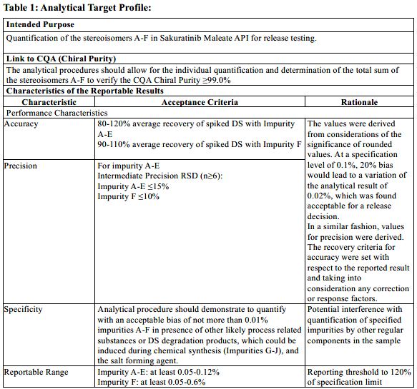  Initial Technology Selection  Multiple analytical technologies for chiral separations were available: Chromatographic methods such as gas chromatography (GC), liquid chromatography (HPLC), supercritical fluid chromatography (SFC) and thin-layer chromatography (TLC) were established technologies using different chiral separation principles. More recently, capillary zone electrophoresis (CZE) and capillary electrochromatography (CEC) had been shown to be alternatives to chromatographic methods. Besides meeting the desired performance characteristics, further practical criteria were considered in the technology selection for development, based on general technical knowledge, operational needs, availability of equipment and capabilities in the company at the time:  • Complexity and robustness of technology  • Time and costs of analysis  • Standardization of technology and availability of multiple instrument suppliers  • Existing expertise in the company  It was finally concluded to start method development with two technologies: Chiral HPLC and CZE. As detection mode, UV detection was selected as it was known that the molecule had sufficient UV absorption properties and standard for both separation techniques at the time.  Analytical Procedure Development  At initial development, a first screening was performed between HPLC and CZE technology. With the technology and columns available at the time, only CZE could meet the expected performance for specificity as described in the ATP, which served as primary endpoint for procedure development. Therefore, the HPLC procedure development was discontinued at initial development.  A risk analysis for the developed CZE procedure was performed. Parameters, where impact on the performance of the procedure could not reasonably excluded were identified. See Ishikawa diagram below:  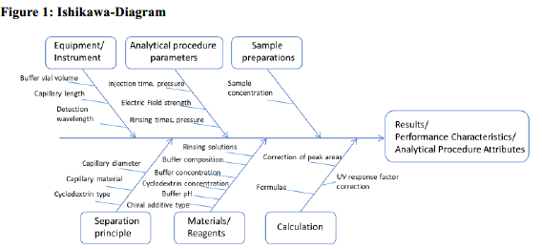  Analytical procedure parameters were investigated and their impact on the performance was evaluated. The robustness of the CZE procedure was optimized and verified versus the performance characteristics. Ultimately, the analytical procedure was optimized in the areas of sensitivity at QL, repeatability of migration times and corrected peak areas, peak tailing of the API and stereoisomers, and separation buffer depletion. Based on the development results, detailed instructions were given in the analytical procedure description “Determination of the stereoisomers A-F in Sakuratinib Maleate” and an SST was established on relative migration times resolution, LOQ, repeatability of injection and the asymmetry of the DS peak as part of the analytical procedure control strategy.  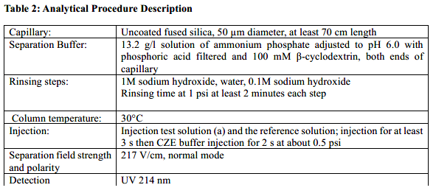  Method validation  After the analytical procedure description was finalized, a technology specific validation study was planned according to the recommendations in ICH Q2. In alignment with the performance characteristics, a technology and procedure specific set of attributes and criteria were derived from the performance characteristics:  - The accuracy was measured by spiking three levels, 0.05, 0.1 and 0.12% for impurity A-E, 0.05, 0.5 and 0.6% for impurity F to the DS salt form at 100% level and the average recovery was calculated. The acceptance criteria for the average recovery of 80-120% and 90-110% respectively were met  - For precision (repeatability), 6 separate preparations of the 6 stereoisomers were made at specification limit. The RSD of 15% (Impurities A-E) respectively 10% (Impurity F) criteria for precision of the migration time corrected peak areas were met. Similarly, intermediate precision between operators, days and instruments were performed and evaluated in an ANOVA experiment.  - Specificity was demonstrated by spiking all 6 stereoisomers to the API salt form and impurities G-J, demonstrating sufficient baseline resolution (no detectable bias between peaks) between the individual analytes of interest and no interference withprocess related impurities. Additionally, blank injections of buffer and water were compared with a sample to demonstrate no interference with the analyte detection.  - To verify the reportable range, a linearity, QL and DL experiment was performed and compared to the technology specific acceptance criteria:  - DL was confirmed to be above a signal to noise ratio of 3:1 for all stereoisomers  - QL was confirmed by demonstrating the RSD of the corrected peak areas for the stereoisomers at the reporting threshold was NMT 10%  - Linearity was found acceptable by demonstrating the correlation coefficient R was greater than 0.998 at 6 levels of stereoisomer concentrations ranging from 0.05-2.0% for all impurities and the drug substance. A wider range was chosen to allow the application of the procedure for a potential wider range and allow a more precise determination of relative UV response factors  - Linearity slopes of the stereoisomers were compared to the linearity of drug substance to demonstrate a UV response factor of about 1.0 for each stereoisomer versus the drug substance  After the performance of the validation study, the results were summarized in a validation report, which concluded that the analytical procedure would meet the acceptance criteria for the analytical procedure attributes. The related performance characteristics were met. The analytical procedure was concluded to be fit for the intended purpose.  Description of Established Conditions (ECs), Reporting Categories, and Justifications  Based on product and process understanding and considering the procedure development data and risk assessment (see introduction to this annex), the applicant proposed established conditions and reporting categories as part of the initial submission. Justification of reporting categories for changes included adherence to predefined acceptance criteria described in the ATP and additional performance controls (e.g., system suitability testing and control samples).  Note: The number of ECs and the associated reporting category listed in this table may depend on the extent of knowledge gained and information provided and is generated for this specific example only. The information provided in this example is not the entirety of the knowledge that is available and will be submitted to regulatory agencies and should not serve as general guidance. The extent of ECs, actual reporting categories, and data requirements may differ by region. Other parameters and conditions that are not identified as ECs in the table below may be required as EC for some cases depending on the region. The changes to other technologies may constitute different risks and may lead to different reporting categories. A PACMP may be required for some cases (e.g., a change between technologies) depending on region.  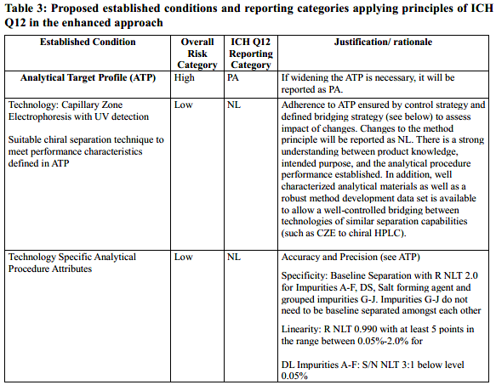  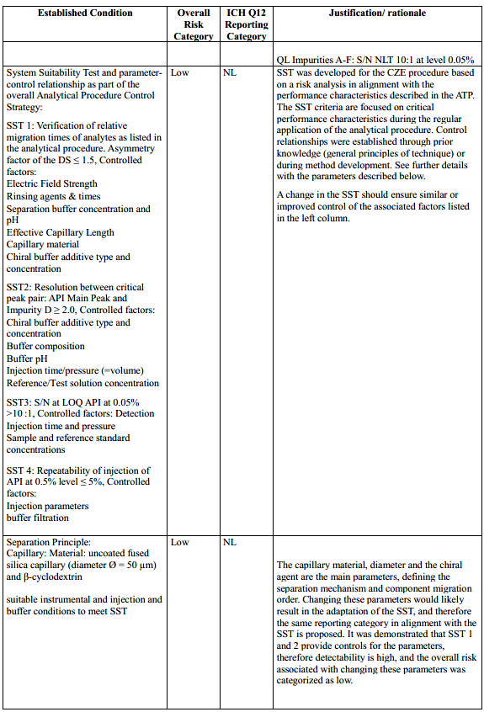  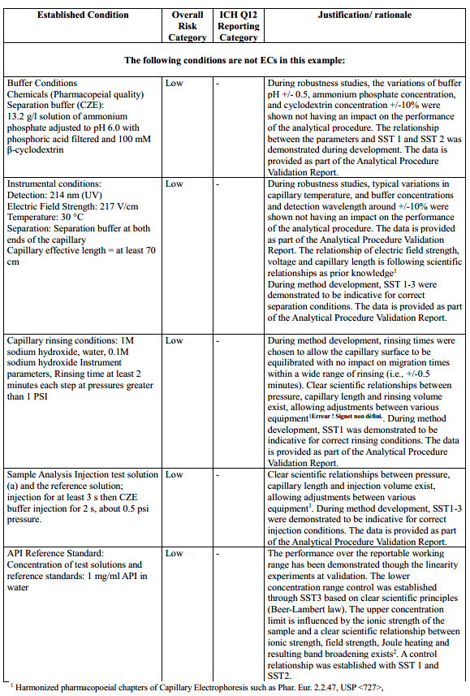  Change assessment and bridging strategy  The assumption is that the information in the table above (ECs and reporting categories) has been agreed upon up front with the regulatory agency.  For every change, the MAH will perform a structured risk assessment to evaluate potential impact on the performance characteristics and the link to CQA (purity) as defined in the respective ATP. As a potential outcome of the risk assessment, experimental bridging studies to demonstrate adherence to the performance characteristics and associated criteria will be performed. These can include, if necessary, partial or full (re-)validation of the analytical procedure performance characteristics affected by the change and/or comparative analysis of representative samples and standards.  The MAH commits to not implement the modified analytical procedure using the predefined reporting category if adherence to the performance characteristics and associated criteria defined in the ATP cannot be demonstrated during the bridging studies. If the precondition of adherence to the ATP cannot be met, a higher reporting category may apply.  Change description and management  The following scenario illustrate examples of post- approval changes and illustrate the steps a MAH would follow when actually implementing the change.  Change #1: Change of buffer pH  Background:  The company has monitored and trended the migration times of the stereoisomers during routine use and found that the migration times could be reproduced in a more stable manner by shifting the buffer pH from 6.0 to 6.5.  Application of Enhanced Understanding  Elements of the enhanced approach (understanding the relationship between SST1 and procedure performance, procedure control strategy) were used to define a control relationship between buffer pH and SST1 and SST 2, as communicated in the submission.  Risk assessment:  The intended change was a change of the analytical procedure parameter, and this was agreed to be managed within the company’s quality system following the adherence to commitments made (i.e., the parameter was not an EC).  a) Risk of change to the patient, product, and manufacturing process (Relevance of the test):  The product is well established and characterized safe and efficacious. The current control strategy of the product is considered as sufficient and will not be impacted by the change. As a result, the specifications for the chiral impurities remain unchanged.  b) Complexity of the technology:  CZE is a well-established technology and the relationship of buffer pH and ionic strength on the zeta potential of the analytes and the capillary surface can be predicted through mathematical equations.  c) Risk of change to the performance of the analytical procedure (Extent of the change)  The extent of the change is low as it is a minor adjustment of the buffer pH  Decision Tree Question #1: Considering product and procedure knowledge and understanding, what is the risk associated with the proposed changes to the reported result?  Answer: Low  Decision Tree Question #2: Are criteria of relevant performance characteristics defined in the dossier which ensure the quality of the measured result after the change?  Answer: Yes  Demonstration of analytical procedure performance after the change  As there is a clear control relationship established between buffer pH and SST1 and SST2, demonstration of meeting the SST criteria is considered as appropriate along with meeting the relevant performance characteristics and associated criteria in the ATP.  Conclusions  Based on the initial risk assessment and the additional controls of SST 1 and SST 2 in place, the risk of changing the buffer pH is considered to be very low.  Proposed Regulatory Reporting  The original agreement with the regulator that this parameter is not an EC was confirmed as a result of the steps that were performed to implement the actual change. Thus, no regulatory reporting is needed. The company will document this change within the PQS.  Change #2: from chiral CZE to chiral HPLC  Background  As chiral column technology had advanced, the company could finally identify a suitable HPLC column and conditions for the intended purpose. The company intends to implement the analytical procedure for the control of stereoisomers of API for release of the final drug in an additional manufacturing site. The company strategy is to use the current (CZE) and future (HPLC) analytical procedures as alternative procedures. A well-established technology, chiral HPLC, is targeted in the alternative development to allow the use of a more standardized technology platform for small molecule drug substances. The intended change is not related to any quality issues of the product, or the established CZE procedure and the company does not intend to modify the specifications for the chiral impurities.  Application of Enhanced Understanding  The anticipated change will neither impact the already established product understanding nor the expected analytical procedure performance, as described in the ATP. Additionally, the fundamentals of the analytical techniques are well understood as general methodology and described in pharmacopoeias. Technology and analyte behaviour are predictable. The product, analytes, and sample preparation are well characterized and understood. Elements of the enhanced approach, such as the clear connectivity between SST and the analytical procedure performance as described in the ATP and risk assessment were applied to make use of the control strategy. Similar enhanced methodology used in the development of the CZE procedure will also be applied for the development of the HPLC procedure.  Risk assessment:  The intended change is a change in technology, and this was agreed as an EC with NL following the adherence to commitments made.  a) Risk of change to the patient, product, and manufacturing process (Relevance of the test):  The product is well established and characterized safe and efficacious. The current analytical control strategy of the product is considered as sufficient and will not be impacted by the change. As a result, the specifications for the chiral impurities remain unchanged.  b) Complexity of the technology:  Only well-established separation technologies (HPLC and CZE) are in scope.  c) Risk of change to the performance of the analytical procedure (Extent of the change)  The performance of the analytical procedure for its intended purpose is described through accuracy, precision, specificity, and result range. The intended change may have an impact on the analytical procedure performance. Therefore, the company has used an analytical target profile as upfront control element to minimize the risk of change.  Decision Tree Question #1: Considering product and procedure knowledge and understanding, what is the risk associated with the proposed changes to the reported result?  Answer: Medium  Decision Tree Question #2: Are criteria of relevant performance characteristics defined in the dossier which ensure the quality of the measured result after the change?  Answer: Yes  Demonstration of Analytical Procedure performance after the change  The procedure will be validated by establishing a technology specific validation protocol and acceptance criteria. The analytical procedure will be validated in alignment with ICH Q2(R2) Annex 2, example separation technique. The acceptance criteria for validation will be derived from the ATP and will result in matching or stricter technology specific tests and criteria. The company has a quality system in place which ensures:  - Appropriate analytical change control and risk evaluation  - The ATP is translated into suitable validation tests and criteria once the technology is selected  - That only analytical procedures will be used and implemented, which fulfill the performance criteria described in the ATP  - Therefore, at any time, the appropriate analytical procedure performance will be guaranteed before its implementation for regular use.  Conclusions  Based on the initial risk assessment and the additional controls in place, the risk of using an HPLC method as alternative method to the CZE method is considered low. The original proposed reporting category of NL was confirmed as a result of the additional assessment and development/validation data.  Proposed Regulatory Reporting  The original EC with associated reporting category as agreed upon with the regulator per Table 3 was confirmed as a result of the steps that were performed to implement the actual change, thus the change will be submitted as notification low.
 | 13.1.2 Measurement of Potency for an anti-TNF-alpha Monoclonal Antibody | Introduction and Background  The example presented refers to the measurement of the relative potency of the drug, in this case an anti-TNF-alpha monoclonal antibody, in drug substance and in drug product at release and for stability testing.  In addition to performing measurements of product CQAs, testing of potency is a unique feature of the release specification testing panel for biologics. Biological activity, measured by the potency, describes the specific ability or capacity of a product to achieve a defined biological effect1 . Often, for complex molecules, the physicochemical information may be extensive but unable to confirm the higher-order structure which, however, can be inferred from the biological activity¹ .  For the purpose of this example, it is assumed that the mode of action of the drug is the neutralisation of the biological activity of soluble TNF-alpha by preventing TNF-alpha from binding to the TNF-alpha receptor. Fc-effector functions are out of scope of the measurement described in the example. For the purpose of this example, it is assumed that the specification limits for the relative potency are 80% to 125% of the activity of the reference standard representative for the product.  During development, forced degradation studies highlighted some modifications in the structure of the molecule as confirmed by physicochemical assays. The potency assay to be developed should be able to detect a change and/or a shift in potency upon forced degradation.  The performance characteristics of the procedure used to generate the reportable result are accuracy, precision, specificity and reportable range. The evaluation of the precision involves variation of the key sources of variability of the analytical procedure such as analyst, days, key reagents (including cell culture parameters, if appropriate), key equipment.  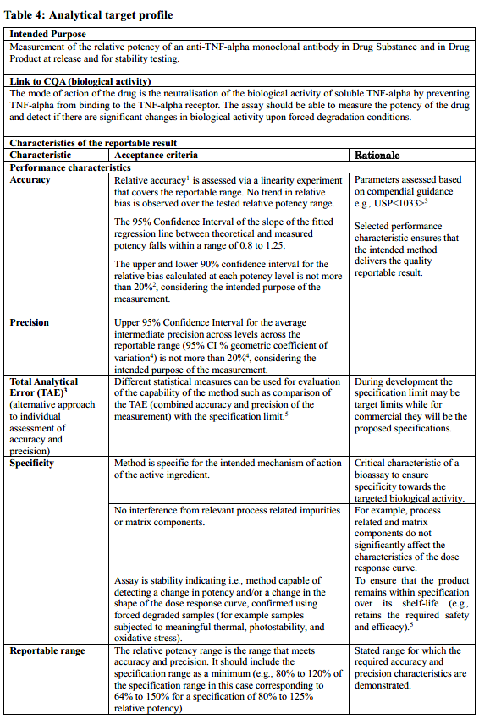  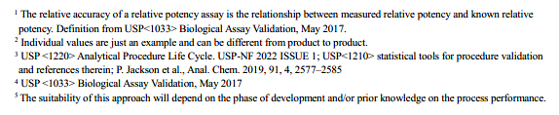  Technology selection:  General considerations  Based on the ATP above, there are several current technologies that may be a suitable choice for the measurement of the relative potency of an anti-TNF-alpha recombinant protein as illustrated in this example.  It is common for the analytical technology for the measurement of potency to evolve during the product lifecycle for biologics, with ELISA-based technologies often being initially utilized prior to the subsequent development of a more technically challenging specific cell-based assay. The two methods rely on the binding of the active substance to the soluble TNF-alpha. While the signal of the ELISA is directly measuring the binding, the cell-based assay may target a later stage event, i.e., a downstream event in the signalling cascade.  Cell-based bioassays can follow several assay methodologies. In the case of anti-TNF-alpha drugs, this includes neutralisation assays, where the assay measures the extent of soluble TNF-alpha-induced cytotoxicity and apoptosis in the presence of the drug. In addition, other formats such as reporter gene assay can be used.  The ATP as described above can also be used in a risk assessment if the technology platform is changed.  Cell proliferation assay as a specific example  In this example, the format of the cell-based assay chosen to measure the relative potency of the anti-TNF-alpha recombinant protein is a neutralisation - cell proliferation assay. It is presumed in this example that the Fc-effector functions are not involved.  The potency will be determined by comparison of dilutions of the sample to be tested with dilutions of the like for like reference standard using a suitable cell-based assay based on the inhibitory action of the drug on the biological activity of soluble TNF-alpha with a suitable readout for assessing the inhibitory effect. The cell proliferation assay was chosen. This assay has the capability to monitor the inhibition induced by the TNF-alpha on the proliferation of a responsive cell line (e.g., murine fibrosarcoma WEHI-164). The assay compares the dose response of a test sample with a designated standard to provide a quantitative measurement of relative potency. The cells are incubated with varying dilutions of test sample and reference standard in presence of TNF-alpha. The cell growth is assessed by a staining method using a tetrazolium salt which is converted by cellular dehydrogenases to a colored formazan product. The amount of released formazan is measured using a spectrophotometer at 450 nm and 650 nm. The spectrophotometric response is directly proportional to the number of living cells.  The throughput of the cell proliferation technology was limited to a small number of samples per day. The test is performed on several 96-well plates and on multiple days. The number of plates run to generate a valid reportable result will be established during the development of the analytical procedure. The equipment required to run this method are commonly used in bioassay laboratories. There are no specific operational nor safety concerns in applying them for bioassay trained analysts.  Analytical Procedure Development  The development of the analytical procedure described has been performed based on extensive knowledge of the molecule and relative potency assays.  The following points are considered in the establishment of the potency assay:  - Purpose and context of the assay defined in the ATP:  - The applicant has extensive knowledge about relevant factors that could impact the CQA (relative potency of the drug) based on CQA assessment and process characterization and has established the link between the mode of action (MOA) and the clinical performance. Based on these data, the appropriate cell line and antigen binding conditions for the potency assay have been selected.  - The molecule is characterized with other functional and/or physicochemical assays that contribute to understanding of the molecule and binding properties (e.g., Fc effector function). The other characterization assays are also continuously used in the lifecycle of the drug.  - Performance characteristics for the analytical procedure are defined (e.g., via the TAE) to support the specification acceptance criteria.  - Relative potency will be calculated for samples as compared to signal from a well-characterized material (e.g., a reference standard) generated in the same analysis.  - Extensive Knowledge was gained from development studies and prior knowledge on:  - The cell line and its performance (viability, cultivation conditions, cell density, cell line stability (e.g., minimum and maximum number of passages) are well understood. Robustness of the cell cultivation conditions ensuring suitable cell metabolism was confirmed during the development of the analytical procedure.  - Criteria for confluence and cell viability have been defined during development to ensure the required cell metabolism and leading to an appropriate signal amplitude and dose response curve.  - Extensive studies have been done to identify the appropriate TNF alpha solution (antigen) leading to a spectrophotometrically measurable sigmoidal dose response curve in the presence of the reference samples or test samples, with lower and upper asymptotes corresponding to negative and positive controls, respectively.  - The assay conditions have been studied and the parameters which influence the assay performance have been identified  - Serial dilution levels were developed to optimize the dose-response curve, e.g., to ensure minimally three points in the linear segment of the dose-response curve and two in each asymptote.  - The relative potency of the reference standard used in the procedure was qualified, and criteria around its performance were established to ensure run-to-run variability remains within suitable limits.  QRM principles were used to guide the design of development studies. Features considered during risk assessment are shown in Figure 2.  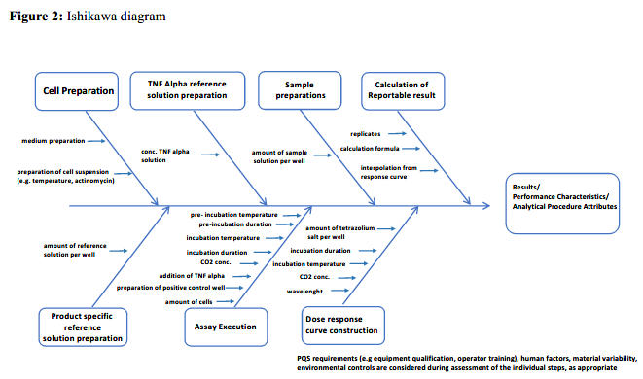  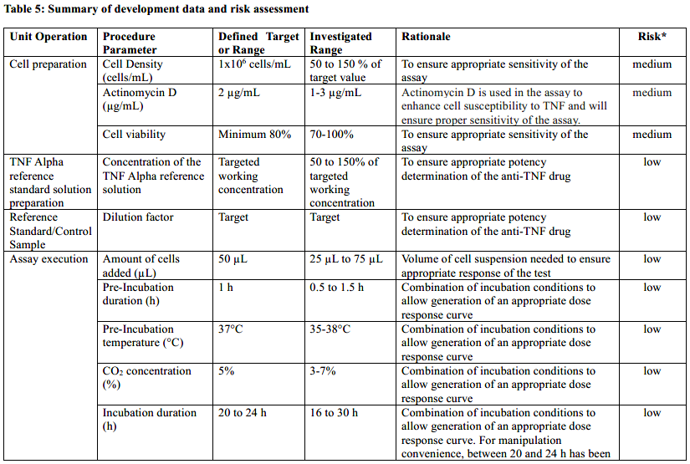  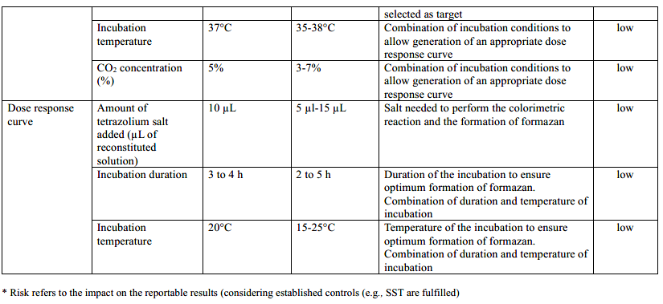  Analytical procedure description²  Equipment:  - 96-well plates  - Tissue culture flasks  - CO2 incubator  - Biosafety cabinet  - Plate reader  Solutions & reagents:  - WEHI-164 cells (ATCC)  - TNF-alpha solution:  o Dissolve the contents of a vial of TNF-alpha according to the supplier’s instructions. Further dilute with assay medium to obtain a suitable working concentration. The cellular response to TNF-alpha varies and a suitable TNF-alpha concentration (e.g., ED80) is determined using a TNF-alpha dose response curve.  - Assay medium composed of RPMI 1640, L-glutamine, heat-inactivated fetal bovine serum (10% v/v) and a penicillin/streptomycin solution (1% v/v)  - Actinomycin D  - Tetrazolium salt WST-8 (5-(2,4-disulfophenyl)-3-(2-methoxy-4-nitrophenyl)-2-(4- nitrophenyl)-2H-tetrazol-3-ium sodium)  - Reference standard  Procedure:  The number of assay plates and days for each sample will depend on the control strategy defined for the method.  - Reference solution and test solution:  o Dilute with assay medium to the appropriate concentration. Analyse in duplicate.  - Plate preparation:  o Add 150 µL of assay medium to the wells designated for ‘cell only control’ and for blanks on a 96-well microplate.  o Add 100 µL of assay medium and 50 µL of TNF-alpha working solution to the wells designated for ‘cell + TNF-alpha control’.  o Add 100 µL of assay medium to the sample wells and 200 µL of the test or reference solutions.  o Further prepare a series of 2-fold dilutions.  o Then add 50 µL of TNF-alpha working solution.  o Incubate at 36.0-38.0°C for 1h in an incubator using 5±2% CO2.  - Cell preparation  o Prepare a suspension of WEHI-164 cells containing 1x106 cells per milliliter, using assay medium containing 2 µg/mL of actinomycin D.  - Plating cells  o Add 50 µL of the cell suspension to each well maintaining the cells in a uniform suspension during addition.  o Incubate at 36.0-38.0°C for 20-24 h in an incubator using 5±2% CO2.  - Addition of tetrazolium salt and absorbance measurement  o Remove 100 µL of medium from each well.  o Add 10 µL of reconstituted WST-8 mixture to each well and reincubate for 3-4 h.  o Measure the absorbance using a microplate reader at 450 nm and 650 nm.  o Estimate the quantity of formazan produced by subtracting the reading at 650 nm  from the reading at 450 nm.  Calculations:  - Calculate the potency of the preparation to be examined using the four-parameter logistic curve model.  - The reportable result is calculated in accordance with the defined number of replicates which is determined during development. Replication strategy may include averaging of the results of multiple plates, typically 3. Individual results within the range of the assay and having passed the sample suitability assessment are used for the calculation of the reportable result.  Analytical procedure control strategy  The analytical procedure control strategy for relative potency determination using the cell proliferation assay (performed as described in the example above) can include the following elements:  System Suitability Test  - The dose-response curve obtained for the reference standard curve corresponds to a sigmoid curve with upper and lower plateaus corresponding to ‘cell only control’ and ‘cell + TNF-alpha control’, respectively.  - The dose-response curve obtained for the test sample corresponds to a sigmoid curve with upper and lower plateaus corresponding to ‘cell only control’ and ‘cell treated with TNF-alpha control’, respectively.  - The coefficient of determination calculated for each standard curve (r² ) is not less than e.g., 0.97.  - Maximum value (cell only) to minimum value (TNF-alpha control) ratio: minimum e.g., 3.0.  Sample suitability assessment:  E.g., Assessment of similarity/ parallelism:  - The upper asymptote ratio (A std/A test): e.g., 0.8-1.2  - The lower asymptote ratio (D std/D test): e.g., 0.8-1.2  - The Hill slope ratio (B std/B test): e.g., 0.8-1.2  - The upper to lower asymptote ratio ((D-A) std/(D-A) test): e.g., 0.8-1.2  Analytical procedure validation according to ICH Q2:  - Validation protocol including predefined acceptance criteria for cell-based assay  o Performance characteristics as defined in the ATP:  ▪ Accuracy  Established by using various starting dilutions to generate different dose response curves  • Acceptance criteria:  o Relative accuracy is assessed via a linearity experiment that covers the reportable range. No trend in relative bias is observed over the tested relative potency range.  o The 95% Confidence Interval of the slope of the fitted regression line between theoretical and measured potency falls within a range of 0.8 to 1.25.  o The upper and lower 90% confidence interval for the relative bias calculated at each potency level is not more than 20%, considering the intended purpose of the measurement.  ▪ Precision  • Acceptance criterion:  Upper 95% confidence interval for the average intermediate precision across the reportable range (95% CI % geometric coefficient of variation) is not more than 20% considering the intended purpose of the measurement.  ▪ Specificity  • Acceptance criteria:  o The method is specific for the intended mechanism of action of the active ingredient, i.e., no dose response curve is obtained (failure of one or more of the assay acceptance criteria) when other biological products are tested using the same method parameters.  o No interference from relevant process related impurities or matrix components, i.e., process related impurities and matrix components do not significantly affect the characteristics of the dose-response curve.  o The assay is stability indicating, i.e., the method is capable of detecting a change in potency and/or a change in the shape of the dose-response curve, confirmed using forced degraded samples (for example samples subjected to meaningful thermal, photostability, or oxidative stress).  ▪ Reportable range  • Acceptance criterion:  The relative potency range is the range that meets accuracy and precision. The reportable range should include the specification range as a minimum (e.g., 80% to 120% of the specification range). In this case, the reportable range corresponds to 64% to 150% relative potency.  o Technology-dependent analytical procedure attributes:  ▪ Linearity of the results  The relative accuracy is the relationship between measured relative potency  and known relative potency.  • Acceptance criteria:  o The upper and lower 90% confidence relative accuracy is assessed via a linearity experiment that covers the reportable range. No trend in relative bias is observed over the tested relative potency range.  o The 95% confidence interval of the slope of the fitted regression line between theoretical and measured potency falls within a range of 0.8 to 1.25.  ▪ Working range of the analytical procedure, i.e., upper to lower levels for which a suitable response curve is achieved. Individual potency results are used to generate the reportable result according to the replication strategy defined in the development.  • acceptance criteria:  o The final reportable result is within the specifications. The individual results agree to a defined RSD, 20%, and are covered by the validation range.  o The validated range of the method is wide enough to encompass the individual result.  - Execution of the validation  The results were summarized in a validation report, which concluded that the analytical procedure would meet the acceptance criteria for the analytical procedure attributes. Implicitly, the performance characteristics were met and, in summary, the analytical procedure was suitable for the intended purpose.  Description of Established Conditions, Reporting Categories, and Justifications  Based on product and process understanding, and considering the procedure development data, the Applicant proposed Established Conditions and reporting categories, as part of the initial submission. Justification of reporting categories for changes includes adherence to predefined acceptance criteria described in the Analytical Target Profile and additional performance controls (e.g., system suitability testing and control samples).  Figure 3 illustrates which analytical procedure steps are relevant for the performance controls defined as established conditions together with the additional continuous performance monitoring enablers.  Table 6 describes the ECs, their reporting categories and justification.  Note: The number of ECs, associated reporting category listed in this table may depend on the extent of knowledge gained and information provided. The information provided in this example is not the entirety of the knowledge that is available and will be submitted to regulatory agencies. The extent of ECs, actual reporting categories, and data requirements may differ by region. Other parameters and conditions that are not identified as ECs in the table below may be required as EC for some cases depending on the region. The changes to other method principles may constitute different risks and may lead to different reporting categories. PACMP may be required for some cases (e.g., a change between technologies) depending on region.  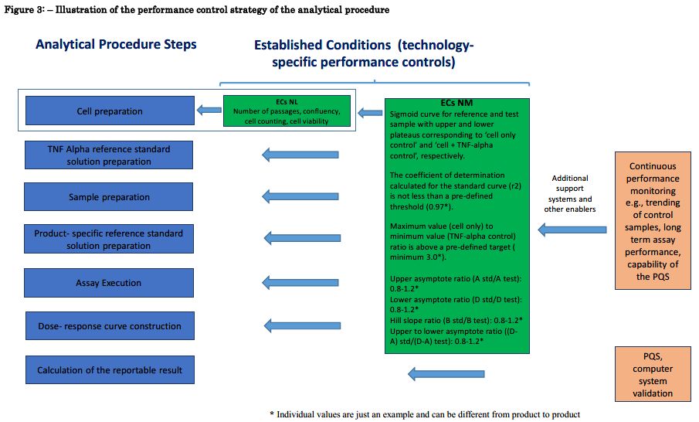  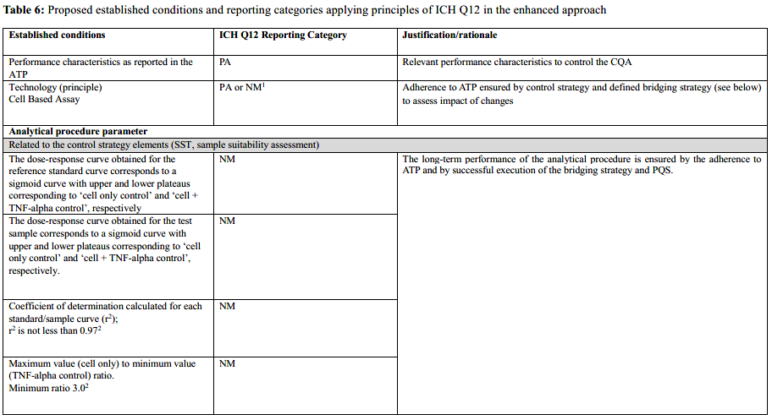  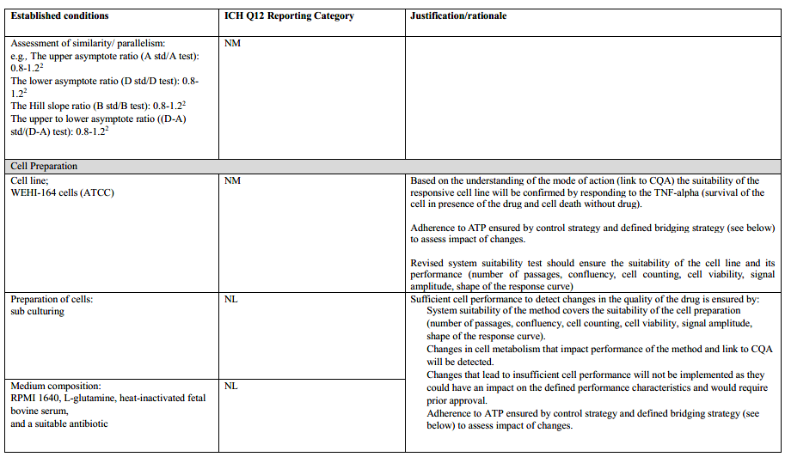  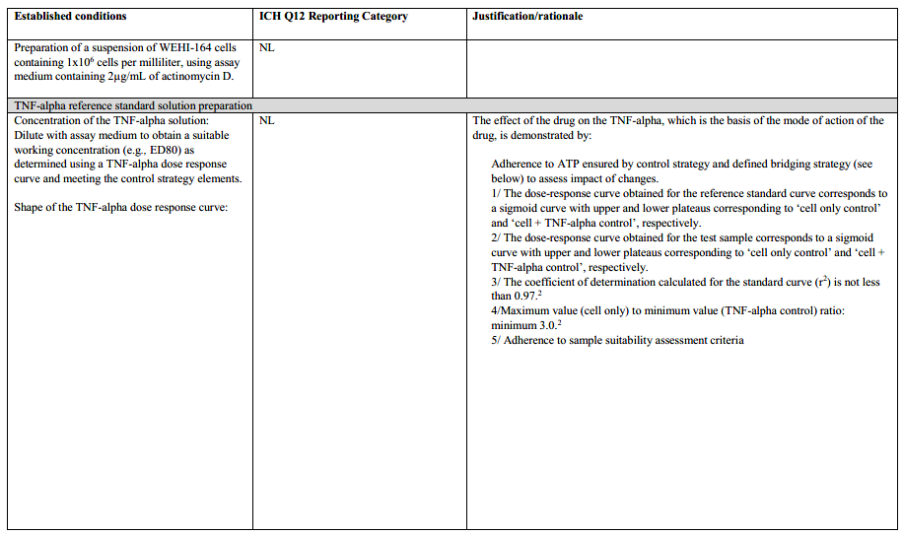  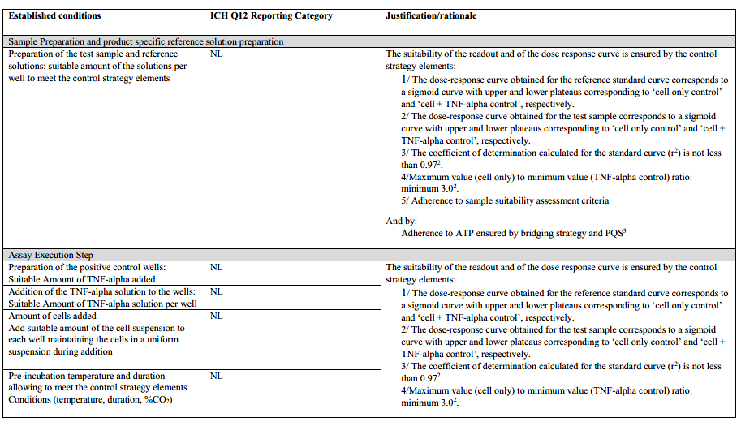  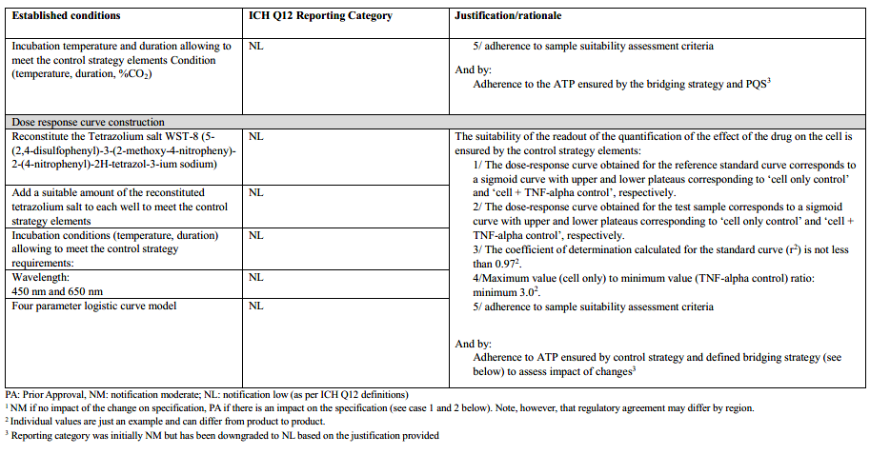  The following parameters are not ECs:  • Preparation of the negative control wells  • Plating format  Change assessment and bridging strategy  The assumption is that the information in the table above (ECs and reporting categories) has been agreed upon up front with the regulatory agency.  For every change, the MAH will perform a structured risk assessment to evaluate potential impact on the performance characteristics and the link to CQA (biological activity) as defined in the respective ATP. As a potential outcome of the risk assessment, experimental bridging studies to demonstrate adherence to the performance characteristics and associated criteria will be performed. These can include, if necessary, partial or full (re-)validation of the analytical procedure performance characteristics affected by the change and/or comparative analysis of representative samples and standards.  The MAH commits to not implement the modified analytical procedure using the predefined reporting category if adherence to the performance characteristics and associated criteria defined in the ATP cannot be demonstrated during the bridging studies.  .  Change Description and Management  The following scenarios illustrate examples of post- approval changes and illustrate the steps a MAH would follow when actually implementing the change.  Change #1: from classical cell culture (continuous cell culture) to ready to use cells (frozen cells)  i) Background of change  Change from continuous cell culture to ready to use cells for cell-based potency assay using the same cell line. This change affects only the analytical procedure step cell preparation. Conditions of freezing and thawing of the cells are the key parameters to control (cell metabolism of responsive cell line) for the success of this change, while the rest of the analytical procedure is unchanged. This change is inside the technology and is not expected to have an impact on the specifications.  ii) Summary of structured risk assessment:  The relevance of the test is classified as high as there is a direct link to the CQA potency, which is key for ensuring the efficacy of the drug. The change is not expected to impact the link to the CQA (same cell line used, same readout) and has low criticality in this respect.  The cell-based assay used for the measurement of potency represents a complex technology as such assays have multiple sources of variability. Factors contributing to variability are well  understood (based on prior knowledge and enhanced development data) and addressed in the analytical procedure control strategy.  The extent of the change is restricted to the preparation of the cells (change in analytical procedure step cell preparation), with potential impact on only one analytical procedure attribute (cell metabolism). Factors contributing to the cell performance are understood, investigated as part of development of the ready to use cell preparation and monitored by the SST.  The initial risk assessment proposed a moderate risk. Further evaluation was performed following Step 2 of ICH Q14 Figure 2.  iii) Adherence to criteria for relevant performance characteristics  The understanding of the analytical procedure and link to the CQA allowed the definition of criteria for relevant performance characteristics which ensure the post change quality of the measured result after the change (please refer to Table 4). The change can potentially affect cell metabolism and hence the method performance characteristics accuracy and precision. Before implementation of the change, adherence to these performance characteristics should be demonstrated. This change does not impact the performance characteristics specificity and reportable range as the same cell line is used and the potency is measured against the same reference standard.  iv) Demonstration of Analytical Procedure performance after change  Evaluation of impact on performance characteristics  Based on analytical procedure understanding the following parameters that could potentially impact the performance have been evaluated and defined in the analytical procedure description: Cell freezing and thawing conditions/cell metabolism are the key parameters to control (freezing medium, freezing conditions, growth/assay medium). The SST of the method covers the suitability of the cell preparation (e.g., confluency, cell density, cell viability, signal amplitude, shape of the response curve).  Experimental Bridging Study Results  In accordance to Table 2 of ICH Q14 a partial revalidation of the analytical procedure was performed to demonstrate the affected analytical procedure attributes are met after the change. Comparative analysis of a set of representative samples with pre- and post-change analytical procedure will be performed to ensure that the achieved results are comparable or that observed differences are acceptable and do not impact the established specification.  v) Conclusion  Evaluation of performance characteristics demonstrated that defined criteria could be met. The result of the studies confirmed the expected cell performance post change. The purpose of the method has not changed and its capability to generate the reportable result is unchanged. Method bridging was successfully performed. The risk associated with the change is considered low taking into account the outcome of the initial risk assessment, the evaluation of the performance characteristics and the bridging study results.  vi) Regulatory reporting:  The original EC with associated reporting category as agreed upon with the regulator per Table 6 was confirmed as a result of the steps performed, thus the change is proposed as notification low. The revised analytical procedure description together with the analytical validation report and the outcome of the bridging study will be submitted accordingly. The SST criteria of the analytical procedure including those ensuring sufficient cell performance remain unchanged. Appropriated development data demonstrating suitable absence of impact on cell performance upon preparation and handling frozen cell will be provided.  Change #2: from binding ELISA to cell-based assay  Another example considers a development scenario where the MAH has initially developed a binding assay (ELISA) to determine the relative potency of the anti TNF alpha recombinant protein and plans to implement a cell-based assay post approval. The measurement requirement as defined in the ATP (Table 4) and included in the initial marketing authorization remained unchanged and were used to support assay development and implementing the change.  i) Background of change:  Change from binding ELISA to cell-based assay. Both methodologies evaluate the relative potency of the drug in comparison to a reference standard. However, the evaluation of the mechanism of action is usually different: Binding ELISA targets early-stage event (binding activity only), while cell-based assay targets late stage event, i.e., downstream event in the signaling cascade. The change from ELISA to a cell-based assay is outside the technology and a potential impact on the specifications acceptance criteria cannot be excluded.  ii) Summary of structured risk assessment:  The relevance of the test is classified as high as there is a direct link to the CQA potency, which is key for ensuring the efficacy of the drug. The change could impact the measurement of the CQA potency as the change is from an immunochemical binding assay to a cell-based assay where also downstream event cascades can be targeted. However, this change is expected to better reflect the mode of action of the product.  The cell-based assay proposed to be used for the measurement of potency represents a complex technology as it is related to multiple sources of variability. Analytical procedure parameters have been evaluated following a risk-based approach and it could be demonstrated that factors contributing to variability are well understood (based on prior knowledge and enhanced development data) and addressed in the analytical procedure control strategy.  The extent of the change is high as a change in technology from an immunochemical binding assay to a cell-based assay is foreseen. The functional properties of the molecule and related mode of action are well understood and supported by preclinical and clinical data. Different responsive cell line candidates have been screened. The WEHI 164 cell line and the assay format (cell proliferation) have been chosen based on predefined selection criteria and the mode of action of the molecule. To address the mode of action of the molecule (anti-TNF), a TNF-alpha standard is used to measure the impact of its addition on the proliferation of the cells in presence of the drug. Optimal amounts of TNF-alpha and of drug have been identified and are described in the analytical procedure. Relevant SST criteria have been defined to ensure the proper control of the analytical procedure (refer to analytical procedure description). The initial risk assessment proposed a high risk. Further evaluation was performed following Step 2 of ICH Q14 Figure 2.  iii) Adherence to criteria for relevant performance characteristics  The understanding of the analytical procedure and link to the CQA allowed the definition of criteria for relevant performance characteristics which ensure the quality of the measured result after the change (please refer to ATP table above). In spite of analytical method principle being different between the immunochemical binding ELISA and the cell-based assay methods, in both procedures the reportable result is measured and calculated relative to the same reference standard allowing data normalisation (RS used as “internal calibrator”). Consequently, the reportable result is expressed using the same approach (% relative potency). However, based on the extent of change a validation of the new procedure including data driven assessment of adherence to the performance characteristics as defined in ATP is required.  iv) Demonstration of Analytical Procedure performance after change  The cell-based assay was developed based on the criteria defined in the ATP. After development, validation of the analytical procedure was performed.  If adherence to the performance characteristics as defined in the ATP can be demonstrated and no change to the specification acceptance criteria is needed, then the bridging studies will be initiated.  However, due to the complex nature of the cell-based assay, the performance characteristics may be affected compared to the binding ELISA (e.g., precision). An assessment should be done to determine if the performance of the assay still meets the criteria described in the ATP and supports the specification acceptance criteria. In case a change of the performance criteria described in the ATP and/or the specification acceptance criteria is needed, the change should follow a pre-approval pathway.  Experimental Bridging Study Results  In accordance to Table 2 of ICH Q14 a full validation of the cell-based procedure was performed to demonstrate the suitability for its intended purpose. The cell-based procedure was found to satisfy the requirements of the ATP. Comparative analysis of a set of representative samples with the ELISA and cell-based analytical procedures was performed including representative degraded samples (forced degraded samples able to detect a loss of potency or end of shelf-life samples). The studies were designed to demonstrate continuity of the results generated with the two methods (e.g., abnormal results should be detected as non-conforming by both methods).  v) Conclusions  Validation of the cell-based procedure and evaluation of performance characteristics demonstrated that the defined criteria were met. The result of the studies demonstrated the ability of both the ELISA and cell-based procedures to measure relative potency with the required levels of accuracy, precision and specificity. The purpose of the analytical procedure had not changed and its capability to generate the reportable result was unchanged.  Method bridging was successfully performed. The change evaluation showed that the extent of change had no impact on the ATP nor on specifications. In addition, the bridging evaluation of the two methods had confirmed that the relative potency specification remained unchanged. The risk associated with the change was considered moderate taking into account the outcome of the initial risk assessment, the evaluation of the performance characteristics and the bridging strategy.  vi) Regulatory reporting  The original EC with associated reporting category as agreed upon with the regulator per Table 6 was confirmed as a result of the steps performed, thus the implementation of the change will be submitted to the relevant regulatory authorities using “Notification moderate” category. The revised analytical procedure description together with the analytical validation report and the outcome of the bridging study will be submitted.
 | 13.2 Annex B: Validation Strategies for MODRs | This annex describes validation strategies for MODRs and includes an example table to present the performance characteristics combined with the attribute acceptance criteria, parameter ranges, control strategy and validation strategy.  ICH Q2 provides the concepts for analytical procedure validation. Generally, the operating space needs to be covered by validation data. The extent of validation activities and the respective operational flexibility associated requires to be assessed and justified on a case-by-case basis. Performance characteristics whose validation is already comprised by development are not considered. Two options below represent examples of typical approaches, allowing also in-between solutions.  Option 1: For validation, at minimum, a single set of univariate operating parameters of the MODR is selected (typically the intended operational conditions or the set point). For future changes of the parameters within the MODR an assessment with regard to additional validation activities should be performed. The strategy for determining the extent of additional validation should be described in the submission  Option 2: The validation of the set point, e.g., center point, and the extrema of the MODR allows full operational flexibility within the MODR without demand for further validation activities.  Figure 1 gives an overview on the lifecycle steps of an analytical procedure showing the impact of the two different validation options.  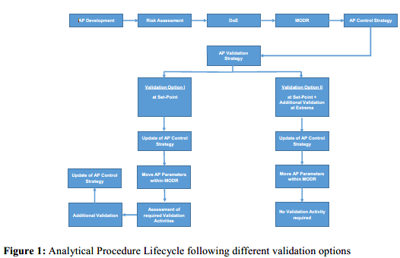  Table 1 represents an approach to summarize the basic knowledge on an analytical procedure and can be used as a consulting resource for changes. It is an example how to compile the core information of an analytical procedure based on the ATP (col. B) and the DoE results (columns D, E, F), leading to the definition of the MODR (col. D) as well as the individual ranges which are shown to fulfil the criteria of specific analytical procedure attributes (col. E). The MODR (col. D) originates common overlap of these individual ranges (col. E), whereas the existing information (col. F) defines the entire investigated range covered by the experiments. At the same time, Table 1 allows to align the acceptance criteria of the analytical procedure attributes (col. B) with the analytical procedure control strategy (col. G) and even to set up an analytical procedure validation strategy (col. H) for the analytical procedure performance characteristics (col. A) derived from ICH Q2. The experimental scheme for future movements of parameters within an MODR can be predefined in the analytical procedure control strategy (col. G).  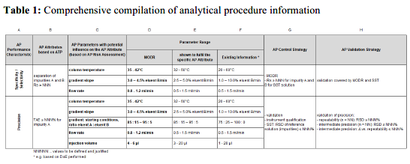
 | 13.3 Annex C: Example of Multivariate Model Lifecycle Components | 