ICH HARMONISED GUIDELINE
ICH Q13: Continuous Manufacturing of Drug Substances and Drug Products
(Draft version, Endorsed on July 27, 2021)
指引意見彙整表
段落 | 標題 | 內文 (摘自Q13 draft guideline，仍以ICH文件為準) | 相關建議及意見  (請提供中英文內容)
PART I: CONTINUOUS MANUFACTURING OF DRUG SUBSTANCES AND DRUG PRODUCTS
1. INTRODUCTION
 | 1.1 Objective | This guideline describes scientific and regulatory considerations for the development, implementation, operation, and lifecycle management of continuous manufacturing (CM). Building on existing ICH Quality guidelines, this guideline provides clarification on CM concepts, describes scientific approaches, and presents regulatory considerations specific to CM of drug substances and drug products.
 | 1.2 Scope | This guideline applies to CM of drug substances and drug products for chemical entities and therapeutic proteins. It is applicable to CM for new products (e.g., new drugs, generic drugs, biosimilars) and the conversion of batch manufacturing to CM for existing products. The principles described in this guideline may also apply to other biological/biotechnological entities.  CM involves the continuous feeding of input materials into, the transformation of in-process materials within, and the concomitant removal of output materials from a manufacturing process. While this description may apply to an individual unit operation (e.g., tableting, perfusion bioreactors), this guideline focuses on the integrated aspects of a CM system in which two or more unit operations are directly connected. In this context, any changes made in a unit operation of CM may have a direct and often immediate impact on downstream and upstream (e.g., via a feedback control) unit operations.  Fundamental aspects of CM that are generally not specific to technology, dosage form, or molecule type are described within the main body of this guideline. Annexes are provided to augment the main guideline by providing illustrative examples and considerations specific to certain modalities (e.g., chemical entities, therapeutic proteins), technologies, and production methods (e.g., integration of drug substance and drug product manufacturing). The examples and approaches described in these annexes are not exhaustive, and alternative approaches can be used. Topics that are broadly applicable to both CM and batch manufacturing are not in the scope of this guideline, and other existing ICH guidelines should be used as appropriate.
2. CM CONCEPTS
 | 2.1. Different Modes of CM | CM can be applied to some or all unit operations in a manufacturing process. Examples of CM modes include:  - A combination of manufacturing approaches in which some unit operations operate in a batch mode while others are integrated and operate in a continuous mode  - A manufacturing approach in which all unit operations of a drug substance or drug product manufacturing process are integrated and operate in a continuous mode  - A manufacturing approach in which drug substance and drug product unit operations are integrated across the boundary between drug substance and drug product to form a single CM process (i.e., the drug substance is continuously formed and processed through integrated unit operations to result in the final drug product)  A manufacturing approach may incorporate surge lines or tanks to maintain a constant flow of material inputs and outputs in any mode of CM described above.
 | 2.2. Batch definition | The ICH Q7 definition of a batch is applicable to all modes of CM, for both drug substances and drug products. Based on this definition, the size of a batch produced by CM can be defined in terms of one of the following:  - Quantity of output material  - Quantity of input material  - Run time at a defined mass flow rate  Other approaches to define batch size can also be considered, if scientifically justified based on the characteristics of the CM process.  A batch size can also be defined as a range. For example, a batch size range can be established by defining a minimum and maximum run time.
3. SCIENTIFIC APPROACHES
 | 3.1. Control Strategy | The development of a successful control strategy for CM is enabled by a holistic approach, considering aspects specific to CM (discussed below) and the principles described in ICH Q8– Q11.
 | 3.1.1. State of Control | A state of control (ICH Q10) is a condition that provides assurance of continued process performance and product quality. The condition may vary, depending on the mode of CM and the specific process steps. For example, a state of control can be demonstrated for some CM processes when a set of parameters (e.g., process parameters, quality attributes) are within specified ranges, but the processes are not necessarily in a steady state condition. Elements of the control strategy monitor a state of control and, when necessary, take appropriate actions to maintain control of the process. It is important to have mechanisms in place to evaluate the consistency of operation and to identify situations in which parameters are within the specified range yet outside historical operating ranges, or they are showing drifts or trends. The latter situation may indicate that the process is at risk of operating outside the specified operating range and warrants evaluation and, when necessary, corrective action.
 | 3.1.2. Process Dynamics | Knowledge of process dynamics is important to maintaining state of control in CM. Specifically, understanding how transient events propagate helps to identify risks to product quality and to develop an appropriate control strategy (see Section 3.1.5 for process monitoring and control considerations). Transient events that occur during CM operation may be planned (e.g., process start-up, shutdown and pause) or unplanned (e.g., disturbances).  Characterisation of the residence time distribution (RTD) can be used to help understand process dynamics. RTD characterises the time available for material transport and transformation, and it is specific to the process, composition/formulation, material properties, equipment design and configuration, etc. Understanding process dynamics (e.g., through the RTD) enables the tracking of material and supports the development of sampling and diversion strategies, where applicable. In addition, such understanding is of importance from a process performance perspective. For example, process dynamics may impact process characteristics, such as selectivity in the manufacture of chemical entity drug substances and viral safety in the manufacture of therapeutic protein drug substances.  Process dynamics should be characterised over the planned operating ranges and anticipated input material variability using scientifically justified approaches. Appropriate methodologies (e.g., RTD studies, in silico modeling with experimental confirmation) should be used to understand the impact of process dynamics and its variation on material transport and transformation. These methodologies should not interfere with the process dynamics of the system, and the characterisation should be relevant to the commercial process. For example, when conducting RTD studies, the tracer used to replace a constituent of the solid or liquid stream should have highly similar flow properties as those of the constituent replaced. A tracer should also be inert to the other components of the process and should not alter how processed materials interact with equipment surfaces. Step testing by making small changes to the quantitative composition of the process stream (e.g., small increments of a constituent) is another useful technique to determine the RTD and avoid the addition of an external tracer to the process. Other approaches can be used; the approach taken should be justified.
 | 3.1.3. Material Characterisation and Control | Material attributes can impact various aspects of CM operation and performance, such as material feeding, process dynamics, and output material quality. Understanding the impact of material attributes and their variability on process performance and product quality is important for the development of the control strategy. Input materials may require evaluation and control of attributes beyond those typically considered for a material specification used in batch manufacturing. For example:  - For a solid dosage form process, particle size, cohesiveness, hygroscopicity, or specific surface area of drug substances and excipients may impact the feeding of powders and material flow through the system.  - For a chemically synthesised drug substance process, viscosity, concentration, or the multiphase nature (e.g., presence of solids) of the feeding solution may impact flow properties or conversion.  - For a therapeutic protein (e.g., monoclonal antibodies) process, the higher variability of feed stocks such as metal salts, vitamins, and other trace components may adversely impact cell culture performance. Prolonged run times may require different lots of media, buffers, or other starting materials for the downstream CM process, potentially introducing more variabilities to the process.
 | 3.1.4. Equipment Design and System Integration | The design of equipment and their integration to form a CM system impacts process dynamics, material transport and transformation, output material quality, etc. When developing a CM process and its control strategy, it is important to consider the characteristics of individual equipment as well as those of the integrated system that can affect process performance. These include the system’s ability to maintain a continuous flow of input and output materials, manage potential disruption to CM operations (e.g., filter changes), and complete the intended transformation of the material stream within the respective planned operational ranges of the equipment. Examples of design considerations are given below:  - Design and configuration of equipment (e.g., compatibility and integrity of equipment components for the maximum run time or cycles; geometry of constituent parts to promote the desired transformation; spatial arrangement of equipment to facilitate material flow and avoid build-up or fouling)  - Connections between equipment (e.g., use of a surge tank between two unit operations to mitigate differences in mass flow rates)  - Locations of material diversion and sampling points (e.g., selection of locations for a diverter valve and sampling probe without interrupting material flow and transformation)  Furthermore, appropriate design or selection of equipment for a CM process may enable process simplification, facilitate process monitoring and material diversion, and improve process capability and performance. For example, in a drug substance process, reactor design can effectively reduce formation and build-up of impurities, resulting in fewer purification steps. Similarly, for therapeutic protein drug substance manufacturing, system design can enable process intensification and reduce cycle times.
 | 3.1.5. Process Monitoring and Control | Process monitoring and control support the maintenance of a state of control during production and allow real-time evaluation of system performance. Common approaches to process monitoring and control—including establishment of target setpoints and control limits, design space, and specifications for attributes being measured—are applicable to CM.  Process analytical technology (PAT) (ICH Q8) is well-suited for CM. Example applications include in-line UV flow cells to monitor therapeutic protein concentration information, in-line near-infrared spectroscopy to assess blend uniformity, and in-line particle size analysis to monitor the output of a crystalliser. The use of PAT enables disturbances to be detected in real time. Therefore, CM is readily amenable to automated process control strategies based on, for example, active control such as feedforward or feedback control. Principles of control strategy as described in ICH Q8 and ICH Q11 can be applied to CM processes.  An appropriate sampling strategy is an important aspect of process monitoring and control. The variables monitored, monitoring method and frequency, amount of material sampled (either physical sampling or data sampling using in-line measurement), sampling location, statistical method, and acceptance criteria depend on the intended use of the data (e.g., detection of rapid changes such as disturbances, assessment of quality of a batch when real-time release testing (RTRT) (ICH Q8) is used, analysis of process trends or drifts) and process dynamics. Another important consideration is the avoidance of measurement interference with the process. Assessment of risks associated with data gaps (e.g., PAT recalibration, refill of a feeding system, failure of system components) should inform whether contingency methods are required.
 | 3.1.6. Material Traceability and Diversion | CM processes may include periods when non-conforming materials are produced, for example, during system start-up and shutdown and when disturbances are not appropriately managed and mitigated. The ability to divert potential non-conforming material from the product stream during production is an important characteristic of CM and should be considered in developing the control strategy.  Understanding the process dynamics of individual unit operations and integrated systems over planned operating conditions enables tracking of the distribution of materials over time. This allows input materials to be traced throughout production. Material traceability, understanding how upstream disturbances affect downstream material quality, and the use of appropriate measurements (e.g., PAT) allow for real-time determination of when to start and stop material collection or diversion. The amount of material diverted can be influenced by several factors, such as process dynamics, control strategy, severity (e.g., magnitude, duration, frequency) of the disturbances, and location of the sampling and diversion points. Additionally, it is important that the diversion strategy accounts for the impact on material flow and process dynamics when material is diverted. Criteria should be established to trigger the start and end of the diversion period and restart of product collection.
 | 3.1.7. Process Models | Process models can be used for development of a CM process or as part of a control strategy for commercial production, including the diversion strategy. Process models may also be used to predict quality attributes in real time, enabling timely process adjustments to maintain a state of control. During development, process models can support the establishment of a design space by explaining how inputs (e.g., process parameters, material attributes) and outputs (e.g., product quality attributes) are related. Through use of in silico experimentation, process models also enhance process understanding and can reduce the number of experimental studies.  For general considerations regarding models (including implications of model impact to validation requirements), refer to Points to Consider: ICH-Endorsed Guide for ICH Q8/Q9/Q10 Implementation. For CM applications, additional considerations are discussed below.  - A process model is specific to system design and configuration and relevant material properties.  - Model development requires an understanding of the underlying model assumptions (e.g., plug flow versus mixed flow systems) and when these assumptions remain valid. Risk assessments, sound scientific rationales, and relevant data are needed to select model inputs and model-governing equations. It is important to determine the relevant inputs that affect the model performance, based on appropriate approaches such as sensitivity analysis.  - Model performance depends on factors such as mathematical constructs and the quality of model inputs (e.g., noise, variability of data). When setting acceptance criteria for model performance, the model’s intended use and the statistical approaches that account for uncertainty in the experimental measurement and model prediction should be considered.  - Model validation assesses the fitness of the model for its intended use based on predetermined acceptance criteria. Model validation activities are primarily concerned with demonstrating the appropriateness of the underlying model assumptions and the degree to which sensitivity and uncertainty of the model and the reference methods are understood.  - Monitoring of model performance should occur on a routine ongoing basis and when a process change (e.g., input material, process parameter change) is implemented. A risk-based approach to assess the impact of a model change (e.g., optimisation of model performance, change of the model’s intended use, change of underlying model assumptions), scope of model development, and model validation criteria enables effective and efficient lifecycle management of models. Depending on the extent of a change and its impact on model performance, a model may need to be redeveloped and validated.
 | 3.2. Changes in Production Output | Several considerations associated with some common approaches to production changes are discussed below, and variations to these approaches are also possible. For already approved products, it is important to justify the selected approach, understand its impact on the overall control strategy and process performance, and, as needed, update the control strategy. Some changes may require process modification and process validation.  - Change in run time with no change to mass flow rates and equipment: Issues not observed over shorter run times may become visible as run time increases. Additional risks and constraints should be considered and may include, for example, process drift, increased heat, material build-up, exceeding the performance limit of components (e.g., validated in vitro cell age, resin cycle number, measurement system calibration status), material degradation, membrane or sensor fouling, and microbial contamination. Decreasing production output (below the longest run time previously validated) should not imply additional risks, given the same equipment, process and control strategy are used.  - Increase mass flow rates with no change to overall run time and equipment: The risks associated with this approach may impact output material quality and are related to changes in process dynamics and system capability to handle increased mass flow rates. Therefore, this approach may require re-evaluation and modification of the control strategy, including process parameters and controls, material traceability, RTD, sampling, and diversion strategies.  - Increase output through duplication of equipment (i.e., scale-out): Considerations for two commonly used scale-out approaches are provided below.  o Replication of production lines (like-for-like): Replicating the integrated CM production line (i.e., same equipment and setup as the original CM system) can be used to increase production output. The replicate production lines follow the same control strategy.  o Parallel unit operations on the same production line: When only some unit operations are replicated on the same line, risks are associated with maintaining control across parallel unit operations. Aspects to consider are maintenance of uniform flow distribution among the parallel operations, re-integration of parallel flow streams, changes to process dynamics, and material traceability.  - Scale up by increasing equipment size/capacity: Depending on the process and equipment design, increasing production by increasing equipment size may be possible. General principles of equipment scale-up as in the case of batch manufacturing apply. As elements such as RTD, process dynamics, and system integration may change, various aspects of the control strategy may be impacted. The applicability of the original control strategy should be assessed at each scale and modified where needed.
 | 3.3. Continuous Process Verification | In CM, frequent process monitoring and control can be achieved through use of PAT tools, such as in-line/online/at-line monitoring and control, soft sensors and models. These tools allow real time data collection for parameters relevant to process dynamics and material quality, and hence ensure the state of control for every batch. Additionally, since CM can facilitate changes to production output without increasing equipment size, there is an opportunity to generate development knowledge at the same scale intended for commercial manufacturing. These tools, together with the system design and the control strategy, facilitate early execution of process validation activities and the adoption of continuous process verification (ICH Q8) as an alternative to traditional process validation.
4. REGULATORY CONSIDERATIONS
 | 4.1. Process Description | In line with ICH M4Q, a sequential narrative description of the manufacturing process should be included in sections 3.2.S.2.2 and 3.2.P.3.2 of the Common Technical Document (CTD) and supported by pharmaceutical development data provided in CTD sections 3.2.S.2.6 or 3.2.P.2.3. In the case of CM, the process description should be supplemented by:  - A description of the CM operational strategy indicating the operating conditions (e.g., mass flow rates, setpoints, ranges), in-process controls or tests, criteria that should be met for product collection during routine manufacturing, and strategy for material collection and, when applicable, diversion  - When appropriate, a description of how the material is transported from one piece of equipment to another (e.g., vertical, horizontal or pneumatic conveying system)  - A flow diagram outlining the direction of material movement through each process step, with the following aspects identified, when applicable:  o Locations where materials enter and leave the process (including material diversion and collection points)  o Locations of unit operations and surge lines or tanks  o Clear indication of the continuous and batch process steps  o Critical steps and points at which process monitoring and controls (e.g., PAT measurement, feedforward or feedback control), intermediate tests, or final product controls are conducted  - A suitably detailed description of any aspects of equipment design or configuration and system integration that were shown during development to be critical to process control or to impact product quality
 | 4.2. Control Strategy | The control strategy of a CM process is designed to ensure that output materials made over the run time are of the desired quality. The control strategy should consider the elements discussed in Section 3 of this guideline. It should describe the relevant controls and approaches used during manufacturing and the operational aspects of the CM process. Some aspects of the control strategy are discussed below.  - Input material attributes: Impact of input material attributes and their variability (e.g., intra-batch, inter-batch, different suppliers) on continuous processing should be assessed and proposed material attribute acceptable ranges should be justified when establishing the material specification. For input materials for which pharmacopoeial requirements exist, characterisation and control may extend beyond those requirements.  - Process monitoring and control: An appropriate description should be provided in the dossier to show a robust approach to monitoring and maintaining a state of control. Approaches on how the control system uses process parameters and in-process material attribute measurements to make process- and quality-related decisions (e.g., to pause the process or divert material) should be described. Other important aspects should be defined, such as the sampling strategy (e.g., location, sample size, frequency, statistical approach and criteria, and their relevance to the intended use), summary of the models if used (e.g., multivariate statistical process control), and the use of data in making in-process control decisions (e.g., to trigger material diversion). Fluctuations or variability that may occur during the CM process should not be masked by the data analysis method used. For example, when data averaging is used, averaging across appropriate time-based intervals should be considered rather than data averaging across the time for an entire CM run. Therefore, statistical sampling plans and data analysis should be described and justified.  - System operation: Procedures should be established and maintained on site for managing system start-up, shutdown, and pauses and for handling disturbances (see Annex V). Relevant approaches for these operations (e.g., handling disturbances) should be described at an adequate level of detail in the dossier. The disposition of material impacted by transient and pause events should be justified, considering potential risks to output material quality (e.g., the impact of a disturbance as it propagates downstream).  - Material diversion and collection: The material diversion and collection strategy should be described and justified. The strategy described should include the criteria for triggering material diversion, the basis for determining the amount of diverted materials, the conditions for resuming material collection, etc. Factors such as sampling frequency, RTD, and amplitude, duration and propagation of disturbances should be considered in developing the diversion strategy. The amount of diverted material should appropriately incorporate justified safety margins, considering the uncertainty of RTD and other measurements. Procedures for managing material collection, diversion, and disposition (e.g., quarantine, offline testing, investigations) do not need to be included in the dossier but should be maintained within the pharmaceutical quality system (PQS) (ICH Q10).  - RTRT: RTRT may be applied to some or all of the output material quality attributes. RTRT is not a regulatory requirement for CM implementation. When RTRT is proposed, the associated reference test method should be described. Development of the data collection approach for RTRT implementation should include a risk assessment of how any lapses in data collection (e.g., recalibrating a near infrared (NIR) probe) may affect decisions relating to product quality. The proposed control strategy should include alternative or additional quality controls to mitigate the risks to product quality posed by these scenarios. If the results from RTRT fail or are trending towards failure, appropriate investigations should be conducted. Refer to Points to Consider: ICH-Endorsed Guide for ICH Q8/Q9/Q10 Implementation for models used as surrogates for traditional release testing methods.  - Equipment and system integration: Aspects of equipment design and system integration that are shown to be critical to output material quality and its control should be described and justified in the context of the overall control strategy.  A summary of the control strategy should be provided in CTD section 3.2.S.2.6 or 3.2.P.2.3 with links to the CTD sections that contain the detailed information to enable the understanding and evaluation of the manufacturing process and how it is controlled.
 | 4.3. Batch Description | The approach to define batch size (see examples in Section 2.2) and the proposed commercial batch size or range should be described in the dossier.  If a range is proposed, it should be justified, and the approach for achieving the range should be described (Section 2.2). Changes in batch size within the proposed batch size range can be managed within the PQS. Any post-approval change to the production output beyond the approved range should be supported by data (Section 3.2) and appropriately managed (i.e., prior approval or notification).  A suitable quantitative metric should be defined to establish batch-to-batch consistency and system robustness. For example, when a batch size is defined by the amount of collected material, the amount of diverted materials relative to that of collected materials for each batch should be considered.  The actual intended size of a given batch should be defined before manufacturing begins and should be managed under the PQS.
 | 4.4. Process Models | The scope of model development, validation, and maintenance and the details provided in the dossier should be commensurate with the model type and impact category. The process model should be specific for the defined system (e.g., equipment, layout, connections). All information for models used as part of commercial manufacturing should be maintained at the manufacturing site. Refer to Points to Consider: ICH-Endorsed Guide for ICH Q8/Q9/Q10 Implementation for regulatory expectations on process models.
 | 4.5. Drug Substance and Drug Product Stability | Regulatory expectations for the stability data package generally do not differ between CM and batch (see, e.g., ICH Q1A, ICH Q5C). The concept of using a pilot scale batch (e.g., at a minimum, one-tenth of a full production scale) for stability studies, as defined in other guidelines (e.g., ICH Q1A), may not be applicable to CM. See Section 3.2 for considerations that should be taken into account if production output between stability and commercial batches is different. Batches used to generate primary stability data should be manufactured using a manufacturing process and equipment representative of the commercial process. Primary stability batches should incorporate the variability described in the ICH stability guidelines (e.g., different drug substance batches or different cell bank vials). Multiple stability batches may be produced from shorter manufacturing runs at the same mass flow rate, provided it is demonstrated that a state of control is established and maintained when the process operates over the longer commercial run times. Alternatively, for chemical entities, a single CM run with a single start-up/shutdown sequence could be used to obtain the stability batches when the aforementioned variability is incorporated into the batches (e.g., by introducing different batches of drug substances in a sequential manner).
 | 4.6. Conversion of a Batch Process to CM | Changing the manufacturing mode from batch to continuous necessitates the development of an appropriate control strategy, considering factors identified in Section 3. The output materials from the batch and continuous processes should have comparable quality. A science and risk-based approach should be used for establishing product comparability and assessing the need for additional bioequivalence, non-clinical or clinical studies, and stability data. Additional details regarding how to establish product comparability for therapeutic proteins can be found in ICH Q5E. Manufacturers should seek regulatory approval before the conversion of an approved batch process to a CM process. Manufacturers can seek advice from the regulatory authority to gain clarification on the regulatory expectations and acceptability of their strategy and data package for the proposed changes (e.g., potential changes in formulation required to enable conversion to CM and the impact of these changes on product registration).
 | 4.7. Process Validation | The requirements for process validation as established in regional regulations and guidance are similar for batch and continuous processes. In addition to a traditional process validation approach that uses a fixed number of validation batches, a continuous process verification approach may be used. The use of a continuous process verification approach should be justified based on the product and process understanding, system design, and overall control strategy.  When continuous process verification is used, the CM system performance and material quality should be continuously monitored, such that the real-time data collected demonstrate the maintenance of a state of control and production of output material with the desired quality for the run time duration. The dossier should contain justifications to support the adequacy of a proposed control strategy for continuous process verification.  When a continuous process verification approach is used to support initial product launch, applicants should define when validation activities are considered sufficient to provide confidence in the commercial manufacturing process.
 | 4.8. Pharmaceutical Quality System | PQS expectations are the same for batch and CM processes and should follow pertinent ICH guidelines. One important operational aspect of CM is that non-conforming materials can be diverted from the rest of the batch when material traceability, process monitoring, and material diversion strategies are well established. Procedures for material diversion, when required, should be established under the PQS (see Section 4.2). Diverted materials resulting from planned events (e.g., system start-up and shutdown) generally do not require investigation when the events meet established process performance criteria. Examples of approaches for managing disturbances are provided in Annex V. As described therein, when unexpected disturbances occur, appropriate investigation, root cause analysis, and corrective action and preventive action (CAPA) should be instituted. An overarching plan or decision tree that describes how disturbances are managed for various categories of material diversion should be maintained under the PQS.
 | 4.9. Lifecycle Management | The principles and approaches described in ICH Q12 are applicable to the lifecycle management of CM. Additional lifecycle management aspects related to conversion of a batch to a CM process for existing products can be found in Section 4.6.
 | 4.10. Submission of CM-Specific Information in the CTD | The dossier should include information as outlined in ICH M4Q. Additional elements relevant to CM should also be provided in the dossier when applicable; some of these elements are listed in Table 1. In the case of integrated drug substance and drug product CM processes, some information and data, such as an integrated flow diagram, may be presented in CTD section 3.2.P with a cross reference in 3.2.S (see Annex IV for additional details).  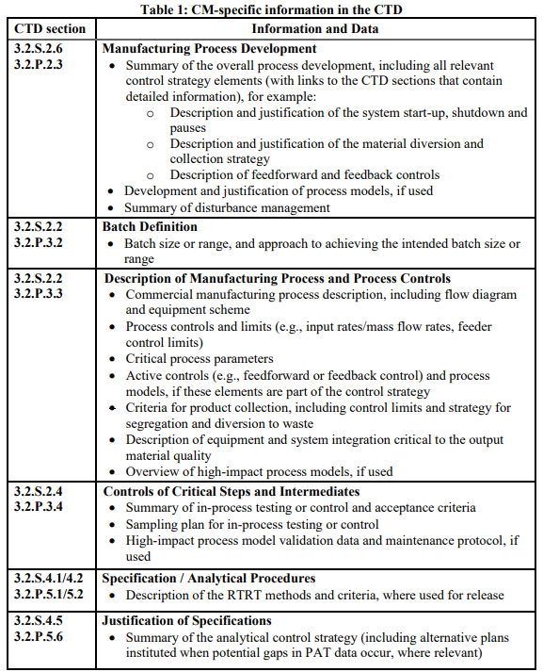  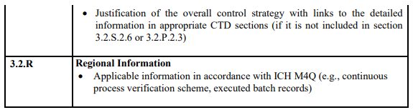
5. GLOSSARY |  | Active Controls:  A system consisting of hardware and software architecture, mechanisms, and algorithms that automatically adjust a process to maintain the process output within a desired range. Examples include feedforward and feedback controls.  Batch (or Lot):  A specific quantity of material produced in a process or series of processes that is expected to be homogeneous within specified limits. In the case of continuous production, a batch may correspond to a defined fraction of the production. The batch size can be defined either by a fixed quantity or by the amount produced in a fixed time interval.  Disturbances:  Unplanned changes to process inputs beyond normal operating range or conditions (e.g., process parameter, material property, equipment condition, or environment) that are introduced into a system.  Diversion:  Procedure in which materials are isolated and separated from the product stream in the manufacturing process.  Material Traceability:  The ability to track the distribution of materials throughout the manufacturing process.  Model Maintenance:  A set of planned activities over the product lifecycle to monitor and sustain the model’s performance to continually ensure its suitability for the intended and approved purpose.  Multivariate Statistical Process Control:  The application of multivariate statistical techniques to analyse complex process data with potentially correlated variables. (EP)  Process Dynamics:  The response of a manufacturing process to changing conditions or transient events.  Residence Time Distribution (RTD):  A measure of the range of residence times experienced by material passing through a specific process environment/vessel/unit operation. (ASTM E2968-14)  Run Time:  The time interval used to produce a quantity of output material.  Soft Sensors:  A model that is used in lieu of physical measurement to estimate a variable or attribute (e.g., a quality attribute of material) based on measured data (e.g., process data). The model development, including selection of such data variables, is driven by comprehensive product and process understanding.  Steady State:  A stable condition that does not change over time.  System:  A manufacturing architecture that, in the context of CM, consists of individual pieces of equipment, their connections to one another and monitoring and control systems, and spatial layout.  Transient Events:  A temporary condition in which a process goes through a dynamic change. This change may be due to a disturbance or an intentional alteration in the selected operating conditions (e.g., start-up, shutdown, changes from one operating condition to another).  Unit Operation:  A basic step in a process. Unit operations involve a physical or chemical transformation such as a reaction, crystallisation, blending, purification, granulation, filtration, and virus inactivation.
6. REFERENCES |  | ASTM E2968-14: Standard Guide for Application of Continuous Processing in the Pharmaceutical Industry  EP: European Pharmacopoeia  ICH Q1A: Stability Testing of New Drug Substances and Products  ICH Q5C: Quality of Biotechnological Products: Stability Testing of Biotechnological/Biological Products  ICH Q5E: Comparability of Biotechnological/Biological Products Subject to Changes in Their Manufacturing Process  ICH Q6A: Specifications: Test Procedures and Acceptance Criteria for New Drug Substances and New Drug Products: Chemical Substances  ICH Q7: Good Manufacturing Practice Guide for Active Pharmaceutical Ingredients  ICH Q8: Pharmaceutical Development  ICH Q9: Quality Risk Management  ICH Q10: Pharmaceutical Quality System  ICH Q11: Development and Manufacture of Drug Substances (Chemical Entities and Biotechnological/Biological Entities)  ICH Q12: Technical and Regulatory Considerations for Pharmaceutical Product Lifecycle Management  ICH M4Q: The Common Technical Document for The Registration of Pharmaceuticals for Human Use: Quality  Points to Consider: ICH-Endorsed Guide for ICH Q8/Q9/Q10 Implementation
PART II: ANNEXES
ANNEX I: CONTINUOUS MANUFACTURING OF DRUG SUBSTANCES FOR CHEMICAL ENTITIES
1. INTRODUCTION AND EXAMPLE SYSTEM OVERVIEW |  | This annex exemplifies one approach to implement CM of drug substances for chemical entities based on the scientific principles described in the main guideline. The discussion points presented here are not exhaustive for drug substance CM systems. Alternative approaches can be used.  Figure 1 illustrates a drug substance manufacturing process containing both continuous and batch operations. It is not intended to represent a regulatory flow diagram. The continuous process segment consists of unit operations that can be characterised as having two plug-flow reactors (PFRs), liquid phase extraction, carbon filtration, continuous crystallisation, and filtration. Manufacture of Intermediate 2 is performed in batch mode, as is final processing including filter drying, milling and packaging. This annex focuses on the continuous elements of this process.  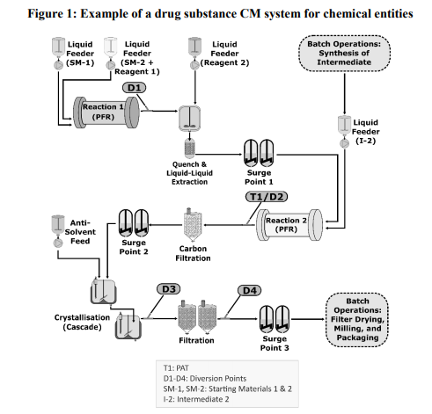
2. CONTROL STRATEGY AND OTHER TECHNICAL CONSIDERATIONS |  | The CM system and its control strategy were designed to control parameters that impact the manufacture and quality of the drug substance, including impurity profile and physicochemical properties. The overall control strategy was developed in accordance with the main guideline and ICH Q7–Q11.
 | 2.1. Equipment Design and Integration | Within the continuous process segment in Figure 1 (Section 1 of this annex), the following processes occur:  - Reaction 1: Starting materials 1 and 2 are coupled in a PFR to produce Intermediate 1. Diversion Point D1 is located after the PFR to permit material diversion when PFR conditions are outside predefined acceptance criteria. The reaction is quenched as an integrated operation after the PFR, and unwanted by-products are removed by liquid-liquid extraction. The resultant solution (Intermediate 1) is used as an input for the second reaction without isolation.  - Reaction 2: Intermediate 1 and Intermediate 2 (prepared upstream through separate batch unit operations) are coupled in a second PFR to form the crude drug substance. The online PAT near the reactor exit (T1) monitors conversion of Intermediate 1 to the crude drug substance. Diversion Point D2 located after PAT is used to divert non-conforming material.  - Drug Substance Isolation: The crude drug substance is purified by carbon filtration and continuous two-stage crystallisation. The crystal slurry is filtered by using two identical filtration units running in an alternating fashion. This setup enables continuous processing of the drug substance after crystallisation by allowing the collection of crystallised products on one filter unit at the same time product isolated on the second filter is discharged. Diversion Points D3 and D4 allow for material diversion at the crystalliser and just before batch operations, respectively. A batch dry milling operation is used to achieve the desired particle size distribution of the crystallised drug substance.  Three surge points (each containing multiple surge tanks) are used: one before Reaction 2, another before the two-stage continuous crystallisation, and one just before final batch operations. These are important components of the system design and control strategy, as they improve process robustness and mitigate temporary differences in mass flow rates by decoupling upstream and downstream operations.  The design of the overall system and each unit operation, along with the control strategy, optimise material quality. For example, PFR design elements (i.e., dimension and configuration) allow precise control of temperature, mixing and reactant flows. These parameters were shown during development to be important to the drug substance impurity profile.
 | 2.2. Process Control and Monitoring | Holistic controls used across Reactions 1 and 2 ensure consistent operations and quality of the resulting crude drug substance. The stoichiometry of Reaction 1 is controlled precisely via control of concentrations and flow rates of the feeds. Conversion of starting materials to Intermediate with minimal impurity formation is ensured through control of the reaction temperature. Reaction 2 is controlled through feedback control of the addition rate of Intermediate 2 based on the PAT measurement of Intermediate 1 levels. This ensures correct stoichiometry for that reaction and minimises the impact of variability of the Intermediate 1 feed solution on drug substance purity. The PAT also measures levels of crude drug substance and process impurities, which confirm successful operation of all preceding steps and consistent product quality.  RTD was used to develop a suitable strategy for disturbance detection, corrective actions, and material diversion. RTD characterisation was based on mathematical modeling of all unit operations and surge points across the entire CM process over planned mass flow rates. The RTD was then confirmed through experimental tracer studies for appropriate segments of the commercial equipment. Decisions for triggering material diversion are based on comparing process parameters and PAT measurements to predefined acceptance criteria with timing and duration of diversion informed by the RTD. Importantly, the RTD is also used for material traceability purposes.  Understanding of process dynamics and its impact on quality attributes of material produced throughout the entire process was also used to guide start-up and shutdown strategies. For example, during start-up of Reactions 1 and 2, a small amount of Intermediate 1 or crude drug substance is diverted at Diversion Points 1 or 2, respectively, to allow those materials to reach the target concentrations before processing into subsequent operations. The criteria for diversion were established based on time considering the RTD. This approach was supported by development studies and confirmed in commercial process equipment. PAT monitoring after Reaction 2 provides additional verification that appropriate criteria have been met during start-up. Collection of material proceeds to the end of the process as subsequently described.  Sampling and process measurement needs were evaluated, considering relevant factors such as residence times (RTs)/RTD, surge points, process dynamics, and the type and purpose of the measurement. The measurement frequency of the PAT at Reaction 2 is sufficient to detect disturbances, inform process adjustments, and ensure timely diversion of material based on predefined criteria. The criteria for material diversion are based on the magnitude and duration of the disturbance, an understanding of process dynamics and RTD for downstream unit operations and surge points, and the impurity purging capability of the crystallisation operation. As a result of this control strategy, all crude drug substance solution that enters continuous crystallisation meets acceptable quality criteria and can be forward processed through the crystalliser.  Appropriate controls and monitoring requirements for the continuous crystallisation were extensively investigated during development in similar, but smaller scale equipment and verified using commercial equipment. Process development included spiking studies using impurity enriched feed solutions and intentional perturbations in process parameters (i.e., feed flow rates, their ratios, and temperatures). An evaluation of the encrusted solids in the crystalliser over extended run times demonstrated the solids were the same form and purity as the free-flowing drug substance slurry. The set of process parameters and ranges identified by these studies were appropriately scaled up. Implementation of these controls along with post-crystallisation material tests (e.g., crystal form, purity) ensure consistent quality of the resulting drug substance throughout continuous crystallisation and filtration.  The resulting material is collected at Surge Point 3 and is dried and milled using batch operations to provide a drug substance of the appropriate particle size for use in drug product manufacturing. Procedures were developed to allow diversion of material at Diversion Points D3 or D4 in the event desired process conditions or material attributes are not met. However, diversion of the drug substance from the crystalliser was found to be unnecessary either during start-up or shutdown.
 | 2.3. Consideration of Other Controls | Process robustness and performance over time are important considerations. A risk assessment was performed to ensure that adequate controls are in place to support the proposed run time (which can be up to several months). It identified a number of considerations and corresponding controls/measures. Examples are summarised in Table 2.  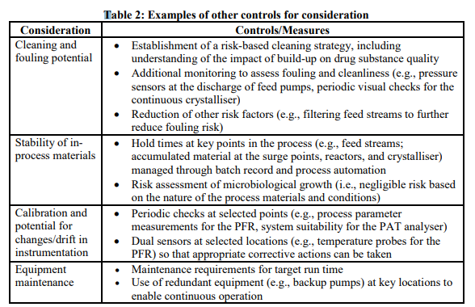  Additionally, specifications for input materials were evaluated during process development. There were no differences between batch and continuous processing for this example.  Collectively, the process understanding developed along with implementation of the various controls described provide a robust and reliable control strategy. This ensures consistent quality of the resulting drug substance including the impurity profile, physicochemical properties, and ability of the system to identify and appropriately react to unexpected events.
 | 2.4. Process Validation | The combination of process controls, online PAT measurements, comprehensive monitoring of process parameters and material attributes, and end-product testing results in a data-rich environment for this process. Together with system understanding generated during development, this enabled the use of a traditional process validation for commercial product launch and continuous process verification to validate process changes over the product lifecycle.  A range of batch sizes was initially established based on material demands and the quantities of material necessary to match input needs of the final batch unit operations. The process was validated using a fixed number of batches. A single planned start-up and shutdown of the commercial CM system was used to manufacture the process validation batches. This approach was supported by the totality of evidence demonstrating the start-up and shutdown capabilities of the system. This included development work on similar equipment, commercial equipment and system qualification data, results of a prevalidation demonstration run, and extensive process monitoring of the CM system that can verify success of each start-up and shutdown in real time.  Subsequently, a continuous process verification approach was adopted after product approval to support increases in batch size with extension of run time. This approach used a risk assessment for the longer run time, which concluded that process performance and material quality would not be impacted. Under the continuous process verification approach, data generated during the manufacture of each batch was used to support successful validation of that batch with the extended run time. This included information such as system performance monitoring and data logs along with other controls that ensure material quality with appropriate detection and corrective action. Additionally, appropriate regulatory actions were taken to communicate this manufacturing change and use of the continuous process verification approach.
3. REGULATORY CONSIDERATIONS |  | Refer to Section 4 of the main guideline. In consideration of the specific CM process design, additional elements may need to be included in a dossier. For instance, in this example, the influence of surge points on the material diversion and collection strategy, including the fate of materials, was described.
ANNEX II: CONTINUOUS MANUFACTURING FOR DRUG PRODUCTS
1. INTRODUCTION AND EXAMPLE SYSTEM OVERVIEW |  | This annex exemplifies one approach to implement CM for a solid dose drug product based on the scientific principles described in the main guideline. The discussion points presented here are not exhaustive for solid dose drug product CM systems. Alternative approaches can be used. Specific considerations relating to the implementation of a continuous direct compression process for a chemical entity are presented.  Figure 2 illustrates a continuous direct compression process that consists of continuous feeding, blending and tablet compression unit operations, with batch-mode film coating. It is not intended to represent a regulatory flow diagram.  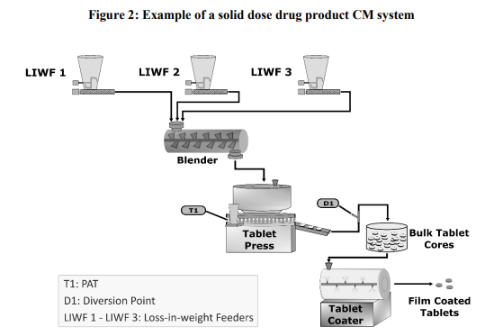  A PAT tool using an NIR method monitors blend uniformity and triggers tablet diversion. Run time at a predefined mass flow rate is used to define the batch size range; in this case, the overall marketing strategy requires batch sizes between 360 and 1080 kg of the drug product.
2. CONTROL STRATEGY AND OTHER TECHNICAL CONSIDERATIONS |  | The CM system and its control strategy were designed to mitigate the impact of disturbances to ensure output material quality. The overall control strategy was developed in accordance with the main guideline and ICH Q8–Q10.
 | 2.1. Material Characterisation and Control | During process development and design, a quality-by-design approach was adopted that identified equipment and process parameters critical to control of the process. Furthermore, the relationships between material quality attributes and their impact on unit operations (particularly the loss-in weight feeders (LIWFs) and blender) and product critical quality attributes (CQAs) were evaluated. Bulk density of the primary excipient and particle size distribution (PSD) of the drug substance were identified as critical to blend and content uniformity. A defined bulk density range and three-tier (d10, d50, d90) PSD specification were implemented for the excipient and drug substance, respectively.
 | 2.2. Equipment Design and Integration | Unit operations and system components (e.g., NIR probe) were designed or selected to mitigate the impact of disturbances on final product quality. The overall design principle is, where possible, to use gravity to move material. During system integration, the material flow was coordinated across all unit operations to avoid material accumulation or emptying. System mass balance was obtained through understanding of material flow (i.e., RT and RTD) at the intended operating conditions of each unit operation. The impact of equipment design and operation on process dynamics was characterised by the RTD of individual unit operations, as well as the RTD of process segments between individual unit operations and the diversion point. The RTDs were determined by replacing the drug substance in the formulation with a tracer that has highly similar flow properties to those of the drug substance.  The following aspects of equipment design and integration were emphasised:  - LIWF: Feeder mass flow rates and their variability were characterised. LIWFs are controlled to deliver the theoretical amount of each input material per the formulation; it was demonstrated that the risks of minor variations to product composition were mitigated by blender mixing capability. Feeder mass flow rates were evaluated using design of experiment (DOE) studies and the proven acceptable ranges of target flow rates were defined. Modelling and statistical approaches (e.g., funnel plots) were used to help determine the limits for the magnitude and duration of disturbances in mass flow rates, for which material diversion, operator investigation, or process stop are needed. LIWFs operate in gravimetric mode unless they are refilling (volumetric mode). Refill aspects (e.g., duration and mass of refill) were evaluated to minimise the impact on feeding.  - Blender: A horizontal blender was selected for the CM system and the blender design was evaluated (e.g., paddle versus ribbon, number and orientation of paddles in the blender, rotation speed). It was determined that a paddle blender is critical to ensure desired blend uniformity. Rotation speed, number and orientation of the paddles were evaluated for their impact on blend uniformity over the ranges studied, and the corresponding design space for the blending process was defined. RTD characterisation provided information on the degree of forward and back mixing and disturbance propagation, and the RTD was used to define the material traceability and diversion strategy.  - NIR probe: The NIR probe was placed in the tablet press feed frame. The chosen NIR equipment met the PAT application requirements (e.g., analysis speed, sampling method, mass flow rate). Probe location and height are fixed; the impact of material build-up was evaluated and found not significant. The system intended for commercial production was used to generate data for the development, calibration and validation of the NIR method.  - Diversion point: The RT between the NIR probe and the diversion point was characterised using a tracer. Using this information, the RTs associated with each unit operation were determined. The material diversion strategy links LIWF and NIR limits to the RT/RTD between the LIWF and NIR as well as the RT/RTD between the probe and diversion point, respectively.  - Coater: The mass in the coater corresponds to 1 hour of production. Coating was designed to be complete in 45 minutes; whilst coating, the next aliquot of tablet cores is filled into the tablet hopper.
 | 2.3. Process Controls and Monitoring | In this system, the LIWFs may introduce fast dynamic disturbances. These may also occur during changes in operating conditions (e.g., during start-up or process pauses). Therefore, monitoring and control of these events are important elements of the control strategy. The control strategy includes NIR measurements, in-process controls (e.g., individual and total flow rates), process parameters including critical process parameters (e.g., blender rotation speed), and active controls (e.g., feedback control of tablet weight). The sampling strategy for monitoring and control reflects the observed process dynamics, therefore ensuring adequate detectability of all relevant disturbances. Together, these aspects enable proactive control of the system and ensure continuous operation in a state of control and accurate material diversion to waste based on the predefined criteria. Unique codes are assigned to predefined batch segments to ensure material traceability and identification of conforming and non-conforming materials. Start-up/restart, pause/stop, and shutdown strategies are defined in Table 3.  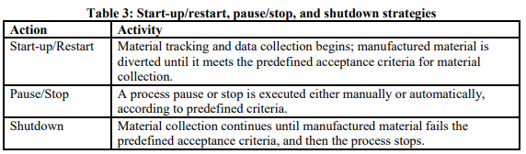
 | 2.4. Process Validation | In this example, the continuous process verification approach was adopted, considering elements such as prior facility experience in implementing a similar CM process and control system (i.e., platform approach), availability of product-specific data arising from late-stage product development using the commercial equipment, the scale independence of the commercial process (i.e., batch size varies by run time), a comprehensive control strategy with high-frequency data collection, and the use of real-time data from every manufacturing run to further support continuous process verification. The control strategy provides real-time monitoring, trending, and prediction analysis through the use of NIR measurements, LIWF data, and other data sources arising from monitoring process parameters (e.g., blender torque), thus providing a high degree of assurance of real-time CM system stability and performance and output material quality. The continuous process verification approach, coupled with appropriate regulatory action for reporting manufacturing changes, was used to validate run time extensions beyond current experience.
3. REGULATORY CONSIDERATIONS |  | Refer to Section 4 of the main guideline. In consideration of the specific CM process design, additional elements may need to be included in a dossier. For instance, in this example, elements that can significantly impact process dynamics and homogeneity (e.g., design space, number of paddles and their orientation in the horizontal paddle blender) were described.
ANNEX III: CONTINUOUS MANUFACTURING OF THERAPEUTIC PROTEIN DRUG 860 SUBSTANCES
1. INTRODUCTION AND EXAMPLE SYSTEM OVERVIEW |  | This annex augments the main guideline by providing additional considerations specific to CM processes for therapeutic protein drug substances and drug substances used as intermediates for subsequent conjugation (e.g., pegylation). It describes aspects that could be applied in fully or partially integrated CM systems. The discussion points presented below are not exhaustive. Alternative approaches can be used.  Figure 3 shows an example of a fully continuous drug substance process for therapeutic proteins (e.g., monoclonal antibodies). It is not intended to represent a regulatory flow diagram. This process integrates a perfusion cell culture bioreactor with continuous downstream chromatography and other purification steps to continuously capture and purify the target protein. Each individual unit operation is integrated with adjacent unit operations, or a surge tank is used in a connection between unit operations. Using a surge tank or line allows continuous operations to accommodate differences in mass flow rates or process dynamics. Other examples of CM systems may use integrated unit operations for selected steps.  In CM processes, a single thaw of one or multiple vials from the same cell bank may result in either a single harvest or multiple harvests. This produces a single batch or multiple batches of drug substance.  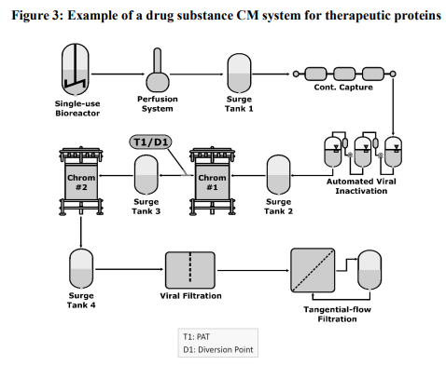
2. CONTROL STRATEGY
 | 2.1. Adventitious Agent Control | In general, all principles used to ensure safety in batch manufacturing are applicable to CM. Safety is demonstrated by a threefold approach based on the principles outlined in ICH Q5A. Control of adventitious agents (e.g., bacteria, viruses, fungi, mycoplasma) should be based on a risk assessment of all potential sources of contamination (e.g., starting and raw materials, manufacturing operations), the ability of the process to remove and inactivate adventitious agents, and the testing capability to ensure the absence of adventitious agents. Based on this assessment, a strategy should be developed to include the type and frequency of adventitious agent testing undertaken to demonstrate that the process remains free of contamination during cell culture and other downstream steps. An aspect unique to CM is extended cell culture duration and continuous processing of harvested cell culture material to obtain drug substances. This means that measures should be in place to demonstrate the acceptability of all cell culture material used to generate a given drug substance batch. Rapid testing for adventitious agents, when possible, may enable real time decision-making to mitigate the impact of contamination events during continuous operation.
 | 2.2. Equipment Design and System Integration | While the use of closed processing equipment may decrease the risk of contamination from adventitious agents, the integrity of single-use equipment during use should be ensured to prevent contamination. The potential weak points (e.g., welds, connectors) and typical locations where single-use systems require changing out over a potentially extended time frame or at a higher frequency for a CM process should be evaluated for potential contamination risks. Filtration steps in CM may be subject to longer filtration periods and potentially increased throughput per unit area or a greater number of filter changes than those under batch manufacturing. Given these factors, a control strategy and a clearly defined scheme should be put in place to allow for filter changes and post-use integrity testing, as appropriate, without interrupting the process. In the event of a filter failure, a clear strategy for material diversion and refiltration (reprocessing) should be defined.  The CM system should contain appropriate sampling locations based on risk assessment to enable detection of inadvertent contamination, while avoiding unnecessary contamination risk introduced through the sampling procedure. The sampling locations and frequency may be adjusted based on improved product and process understanding.  Integrated systems may use surge tanks for flow rate adjustments or other purposes between steps such as virus inactivation. When surge tanks are used, the relevant RTD, uniformity and microbial risks to the product in these surge tanks should be evaluated and defined in advance.  When considering the facility design for a CM process, either closed systems in an open architecture (ballroom) layout or open systems with physical segregation of post-viral filtration material could be used with appropriate justification.
 | 2.3. Process Monitoring and Real-Time Release Testing | CM lends itself to various monitoring schemes with different levels of automation. Examples include in-line sensors placed directly in a process vessel or flowing material stream and online analysers that conduct automatic sampling. Regardless of the approach used, appropriate monitoring at suitable stages of the CM process enables timely data analysis to ensure operations are in a state of control. In certain cases, relevant process parameters may be adjusted to ensure the quality of in-process or output materials. Enhancing in-line/online PAT capabilities and development of automation systems for process monitoring enables a continuous monitoring scheme in support of a release testing strategy that may include RTRT for some quality attributes. Conventional offline testing for product release is necessary for quality attributes for which analytical technologies are not available for online or in-line measurements (e.g., potency). Likewise, conventional tests for monitoring and control (e.g., microbiological analytical methods and other tests that require long processing times) might also be needed.
3. PROCESS VALIDATION
 | 3.1. Approaches to Process Validation | Process validation approaches used for processes run in batch mode are also applicable to CM processes. Therefore, the scope of validation continues to be to demonstrate the ability to consistently manufacture a product with the desired quality attributes.  For therapeutic protein CM, any approach chosen to demonstrate the consistency of process performance and product quality should consider all potential sources of variability. This may include variability between batches purified from harvest materials collected up to the limit of in vitro cell age from a single cell bank thaw, as well as the potential variability between different batches purified from harvests of multiple cell bank thaws. Variability may be evaluated either as part of process qualification or through alternative studies, if justified. For some unit operations, the use of scale-down models remains an alternative approach to validation (e.g., viral clearance), if justified.  Alternatives to the process validation approaches (e.g., continuous process verification) may be considered when justified. Refer to Sections 3.3 and 4.7 of the main guideline for more details regarding continuous process verification. Additionally, elements such as risk assessment, the applicability of small-scale development data, process models, and experience with molecules that are sufficiently alike with respect to their CM process may be considered in determining the suitability of a continuous process verification approach.
 | 3.2. Run Time Considerations | Bioreactors for CM may operate for significantly longer periods of time than bioreactors for batch manufacturing. The approach to establish a limit of in vitro cell age for production cells does not differ, regardless of the mode of bioreactor operation. Previously established limits of in vitro cell age for a bioreactor operating in a batch mode run may not be applicable to a bioreactor operating in a continuous mode under different culture conditions. The limit of in vitro cell age used for production should be based on data derived from production cells expanded under pilot-plant scale or commercial-scale conditions to the proposed in vitro cell age or beyond as outlined in ICH Q5A.  Run time considerations should include factors such as the control of all adventitious agents (e.g., viruses, bacteria, fungi, mycoplasma) and the impact of resin and membrane lifetimes. Viral testing should be conducted as outlined by ICH Q5A, and an appropriate microbial control strategy should be established.
 | 3.3. Viral Clearance Validation | The general recommendations outlined in ICH Q5A for viral safety and clearance remain applicable for CM. Where recommendations may not be applicable to a CM system, scientifically justified alternatives may be proposed.  Considerations specific to CM in aspects such as qualification of small-scale models are addressed in ICH Q5A.
ANNEX IV: INTEGRATED DRUG SUBSTANCE AND DRUG PRODUCT 980 CONTINUOUS MANFACTURING
1. INTRODUCTION |  | This annex augments the main guideline by providing additional considerations for the development and implementation of an integrated drug substance and drug product CM process (referred to as integrated process hereafter). An integrated process for a small molecule tablet dosage form is used for illustration. The illustrative example and approaches described in this annex are not exhaustive. Alternative approaches can be used.
2. INTEGRATED SMALL MOLECULE DRUG SUBSTANCE/DRUG PRODUCT PROCESSES
 | 2.1. Characteristics of Drug Substance and Drug Product Process Steps | Considering the differences between the drug substance and drug product process steps enables appropriate design of an integrated process. For example, process steps for drug substance and drug product manufacturing may have different RTs, and a prevalence for liquid or solid input material addition can lead to a different frequency of in-process measurements. These differences may influence the selection of equipment, equipment connections, surge lines or tanks, and the locations of in-process measurements and material diversion.
 | 2.2. Example of an Integrated Process | Figure 4, which is not intended to represent a regulatory flow diagram, illustrates a fully continuous integrated drug substance and drug product process. It shows the following elements:  - Material addition points for liquids and solids  - Each process step used for drug substance and drug product manufacturing  - Process design for the interface between the drug substance and drug product  - Sampling locations for all in-line/at-line/offline measurements, including PAT (shown by 1008 T1–T5)  - All diversion points (shown by D1–D4)  In this example, chemical reaction using flow reactors, continuous crystallisation and crossflow filtration are used to obtain the drug substance as a highly concentrated crystal slurry. The selection of a wet granulation process for the manufacture of tablet drug products permits the drug substance and drug product processes to be integrated through the continuous filtration line. The concentrated crystal slurry functions as both the drug substance source and the granulation fluid. No surge lines or tanks are used.  Other process schemes—including, for example, different purification methods, surge tanks, mix of batch and continuous unit operations—could also be used in the design of an integrated process. If the process design does not involve isolation of crystals, then details should be provided on how drug substance purity is ensured.  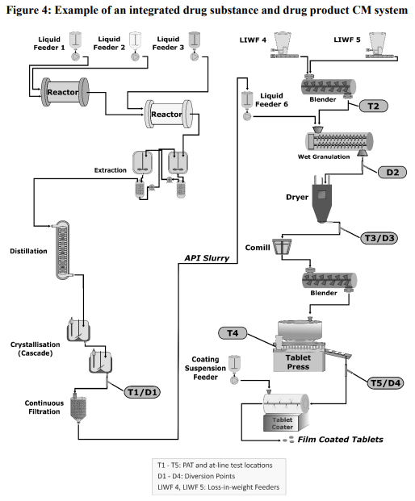
 | 2.3. Process Design, Monitoring and Control | Figure 4 illustrates how the monitoring points create several process segments (i.e., from the first drug substance reactor up to location T1, process steps from T1 to T2, etc.). The sampling strategy could be based on RTD characterisation of individual steps, process segments or the entire process. In this example, the RT/RTD of the drug substance process segment provides a suitable time frame to monitor drug substance quality in real time, considering an appropriate sampling frequency, test method, time needed for measurement, and instrument capability. Location T1/D1 is used for sampling drug substance for offline testing or for diversion of drug substance, as necessary. Diversion of material impacts mass flow and may require a compensation strategy in the downstream operations considering the RTD.  Allowable variations (including minor disturbances) identified through DOE or other suitable studies are incorporated into the process control strategy. For example, the process parameter ranges for material additions and reactors, as well as the magnitude and duration of an allowable disturbance, could be based on the variations shown to be within the purification capability of the crystallisation step, so there would be no adverse impact on the drug substance purity and impurity profile. An additional risk-based safety margin is included in the established thresholds to ensure all non-conforming material is diverted. Variations outside these thresholds result in material diversion using a suitable method for material traceability (e.g., RTD model).  Ongoing assessment of equipment performance helps predict and prevent potential problems and ensures the ability of a CM process to operate as intended over time. Two such examples are: (1) during continuous filtration, monitoring filter back pressure to evaluate filter saturation (maximum pressure) and prevent filter failure; and (2) during material feeding using LIWFs, monitoring the feeder screw speed in relation to its maximum capacity to inform low feeder fill-level. Monitoring 1053 of equipment performance could be used to support how process control will be ensured, especially during long run times.
 | 2.4. Start-up and Shutdown | Individual unit operations of an integrated drug substance and drug product process could achieve its desired operating conditions at different times due to differences in the type of transformation (e.g., chemical versus physical transformation) and the RT in the equipment. When such differences occur, careful planning of start-up and shutdown sequences enables faster product collection and reduces waste.
 | 2.5. RTD Characterisation for System Dynamics and Material Traceability | Refer to the main guideline for RTD characterisation. An integrated process may use different approaches or tracers to characterise various process segments considering aspects such as liquid and solid flow streams.
3. SPECIFICATION AND BATCH DATA
 | 3.1. Drug Substance Specification | Even though the drug substance is not isolated in an integrated drug substance and drug product process, a drug substance specification should be defined and justified in accordance with ICH Q6A and other relevant ICH guidelines. Institution of a drug substance specification defines the quality of the drug substance, as well as facilitates the management of lifecycle activities (e.g., facility changes), investigation of adverse events and product recalls, and development of pharmacopeial monographs.  Although a drug substance specification is instituted, drug substance testing may not be required on a routine basis when the integrated process is appropriately controlled. A set of process performance criteria can be defined such that the drug substance could be considered “conforms to specification, if tested” when those process performance criteria are met. To ensure there is a comprehensive monitoring of the quality of the drug substance during the lifecycle of the product, conformance to the drug substance specification should be verified on a periodic and event-driven basis by testing the purified drug substance at an appropriate location using a relevant sampling plan. The frequency of the periodic verification should be defined and justified. Drug substance periodic verification can be based on the frequency of drug product production and time. Event based verifications could be triggered by a change in supplier, starting material, synthesis conditions, or other factors considering risk. Refer to ICH Q6A for additional details on periodic testing.  Appropriate sampling locations should be incorporated into the process design to enable testing of the drug substance (e.g., location T1 in Figure 4). Any modifications made to the sample to enable the test (e.g., drying of the crystal slurry for testing crystalline form) may be incorporated into the test methodology. Sampling locations should be identified in the drug substance specification.  Although the drug substance is not isolated, a discussion of the origin and fate of potential impurities (e.g., related substances, residual solvents, catalysts), robustness of impurity clearance, and impurity carryover from the drug substance into the drug product should be provided in the dossier. The control of impurities formation and clearance should be integrated into the overall control strategy.
 | 3.2. Drug Product Specification | In integrated processes, attributes typically associated with the drug substance quality are generally included in the drug product specification unless justified per ICH Q6A. Therefore, the drug product specification in an integrated process is more extensive than that of a batch process and may include drug substance related substances, residual solvents (used in drug substance synthesis), elemental impurities, etc., when appropriate. The specified impurities in the drug product specification may differ from the specified impurities in the drug substance specification (e.g., mutagenic impurity).  Sampling location should be appropriately identified in the drug product specification table, as some testing (e.g., testing for drug substance periodic verification as described above) may need to be performed following the drug substance purification step (before drug product formation).  An example of a drug substance and drug product testing approach for an integrated process is shown in Table 4. The test attributes listed are considered relevant for this example. The specific details of each integrated process should be considered in the selection of the appropriate test attributes and testing plan.  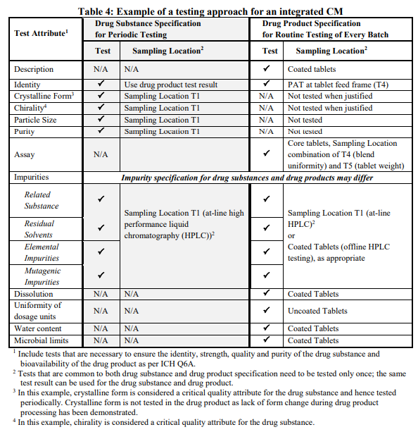
 | 3.3. Batch Data | Although the drug substance is not isolated, small, planned diversions during process development could be used to obtain batch data that is representative of commercial drug substance.
4. STABILITY REQUIREMENTS
 | 4.1. Drug Substance Stability | Drug substance stability data to define a re-test period is not applicable as the drug substance is not isolated and stored in an integrated process. However, institution of a hold time enables temporary storage of drug substance during an interruption in production. In the absence of data to support a hold time, drug substance formed during a process interruption should be discarded. Drug substance stability data may be appropriate for other aspects, such as to support the storage of in-house reference standards and to gain an understanding of product stability profiles.
 | 4.2. Drug Product Stability | The ICH stability guidelines and Section 4.5 of the main guideline are applicable.
5. LOCATION OF DRUG SUBSTANCE AND DRUG PRODUCT INFORMATION IN THE CTD |  | Drug substance and drug product information could be provided in the respective CTD sections 3.2.S and 3.2.P of the dossier as per ICH M4Q. A description of the process step that integrates the drug substance and drug product could be based on its relevancy to the respective section. For example, in the process example provided in this annex, the continuous filtration process could be described in CTD section 3.2.S as it is related to concentration of the drug substance. The integrated flow diagram can be provided in CTD section 3.2.P and referenced in section 3.2.S.
ANNEX V: PERSPECTIVES ON MANAGING DISTURBANCES
1. INTRODUCTION |  | This annex describes examples of approaches for managing transient disturbances (hereafter referred to as disturbances in this annex) that may occur during CM. The discussion points presented here are not exhaustive. Alternative approaches can be used.
2. BACKGROUND |  | Disturbances may result in product quality variation. Some quality variations in an earlier process step may be resolved by downstream process steps. The extent of quality variations and the ability to resolve them in subsequent steps are impacted by the amplitude, duration and frequency of the disturbance. Identification of tolerable ranges for these parameters and establishing appropriate acceptance criteria will enable the development of an effective strategy for managing disturbances.  Manufacturers may use various methodologies (e.g., DOE, RTD studies or a combination of both) to understand the impact of disturbances. Funnel plot predictions based on an RTD model can be a useful tool to understand the qualitative and quantitative impact of the amplitude and duration of a disturbance on material quality. Figure 5 shows a funnel plot for drug substance feeding in a drug product CM process (similar to the example in Annex II). Funnel plots are specific to the formulation and process conditions used in RTD model development. Information from the funnel plots helps to inform the selection of appropriate acceptance criteria for disturbances. For example, the dotted lines in the following funnel plot show that a disturbance of +/- 20% lasting less than 90 seconds would not cause the drug concentration in the blend to exceed the 90–110% label claim (LC).  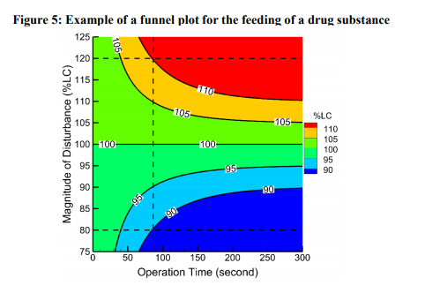
3. MANAGEMENT OF DISTURBANCES |  | Manufacturers may develop various approaches to manage disturbances considering the specific details of the CM system and risks of a disturbance. Three examples considering different risks of a disturbance are provided below:  - Example 1: The amplitude and duration of the disturbance meet predefined acceptance criteria for the disturbance, and the occurrence of such disturbances is infrequent.  - Example 2: The amplitude or duration of the disturbance exceed the predefined acceptance criteria for the disturbance, and the occurrence of such disturbances is infrequent.  - Example 3: The amplitude and duration of each disturbance meets predefined acceptance criteria for the disturbance, but multiple, frequent disturbances are observed.  These common examples focus on the impact of disturbance from an LIWF on the drug concentration in the blend for a CM process similar to that described in Annex II, given that all other parameters being monitored meet the predefined acceptance criteria. These examples use the information in the funnel plot (Figure 5) and, for the purpose of discussion, assume that the acceptance criteria for the magnitude and duration of an LIWF disturbance is +/- 20% lasting for 80 minutes. These examples help illustrate the important considerations in management of disturbances under selected scenarios, which may also be applicable to drug substances and other CM processes.
 | 3.1. Disturbance Example 1 | 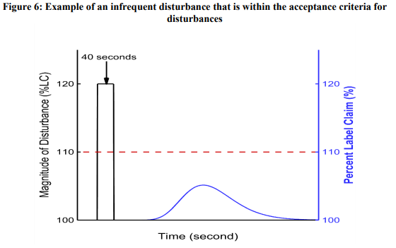  Description: Figure 6 illustrates a drug substance LIWF with an infrequent transient +20% flow spike lasting 40 seconds, which is within the predefined acceptance criteria for disturbances. This disturbance causes an increase in the amount of the drug substance fed into the blender, before returning to normal operating condition. The funnel plot (Figure 5) shows that following this disturbance, the drug substance concentration in the blend remains within the 90–110% acceptance criteria, due to back mixing. An additional quality check, such as measurement of the drug substance concentration at a suitable location (i.e., NIR measurements at the tablet press feed frame), confirms the blend is within 90–110%.  Impact: Although this disturbance represents an excursion from normal operation, the quality of the output material is not affected as the magnitude/amplitude of the disturbance and product quality meet their predefined acceptance criteria.  Action: No material is diverted. Collection of the output material continues, and the process continues to operate. No investigation is needed, because such a disturbance has been evaluated during development and its origin and impact on material quality are understood.
 | 3.2. Disturbance Example 2 | 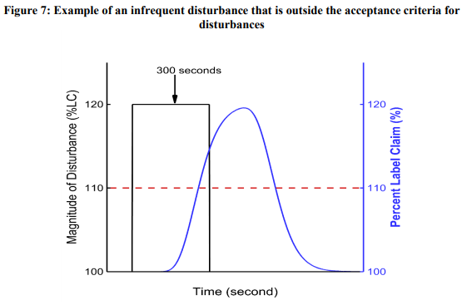  Description: Figure 7 illustrates a drug substance LIWF with an infrequent transient +20% flow spike lasting seconds. The disturbance is outside the predefined acceptance criteria for disturbances. This disturbance causes an increase in the amount of the drug substance fed into the blender before returning to normal operating condition. The funnel plot (Figure 5) shows that following this disturbance, the drug substance concentration in the blend exceeds the 90–110% acceptance criterion. An additional quality check, such as measurement of the drug substance concentration at a suitable location (e.g., NIR measurements at the tablet press feed frame), confirms the blend exceeds 110%.  Impact: The quality of the output material is adversely impacted as the disturbance duration exceeds the predefined acceptance criteria.  Action: The process continues to operate while the non-conforming material is diverted according to a pre-established procedure, and the time to start and end diversion is controlled by the automation system. The system returns to normal material collection mode when the non-conforming material is completely diverted. A concurrent investigation should be initiated to determine root cause.  Diverted Amount: The amount of material diverted depends on the control strategy used (including specific triggers for material diversion) and on the process dynamics from the point of disturbance detection and the point at which material diversion ends. Inclusion of the confidence intervals in RTD provides a safety margin to ensure all non-conforming material is diverted from the batch. Additional factors, such as the sampling strategy and the ability to trace and remove materials, are considered in establishing the criteria for material diversion.
 | 3.3. Disturbance Example 3 | 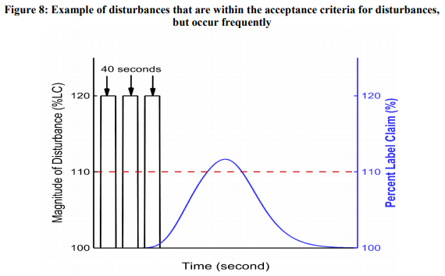  Description: Figure 8 illustrates a drug substance LIWF with multiple frequent transient +20% flow spikes, each lasting 40 seconds, resulting in variability in the amount of material fed into the blender.  Impact: Although each disturbance meets the predefined acceptance criteria for disturbances, they occur with a high frequency over a short time period. In this example, the system cannot dampen these multiple disturbances sufficiently, thus resulting in non-conforming materials.  Action: The impact of these disturbances on system performance and output material quality is monitored closely (e.g., NIR method, other elements of the control strategy). Process operation and product collection continue until one or more elements of the control strategy do not meet the predefined acceptance criteria. When a criterion is no longer met, the material is diverted according to a pre-established procedure. If high-frequency disturbances persist, process operation may be paused. An investigation is conducted to understand the root cause for these frequent disturbances. Such investigations enable preventative actions to be taken to avoid equipment failure and adverse impact on critical quality attributes, ensure process performance (e.g., robustness), etc. Assessment of process capability or other evaluations may also be warranted. Setting acceptance criteria for the frequency of disturbances could also be considered to aid the management of disturbances.  Diverted Amount: The amount diverted is the same as described in Section 3.2 of this annex. The 1269 disposition of the diverted material and the entire batch is assessed upon completion of the 1270 investigation.
 | 3.4. Summary | Figure 9 outlines the likely scenarios, possible risks, and mitigation strategies of the above three examples.  